Instructions for borrowing e-books in the on-line Catalogue

- Log in to the on-line Catalog using your account - it is necessary to borrow an e-book.

- To find e-books in the on-line Catalog, use the search option.

- In the list of search results, e-books are displayed with the annotation "you can borrow on-line".

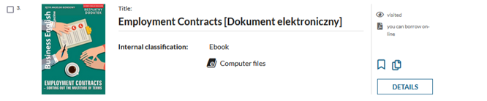

- To borrow a selected e-book, go to Details, and then click Borrow on-line.
- The system will automatically take you to the Borrowed items section. There are borrowed e-books. To use them, click Actions, then Browse PDF.
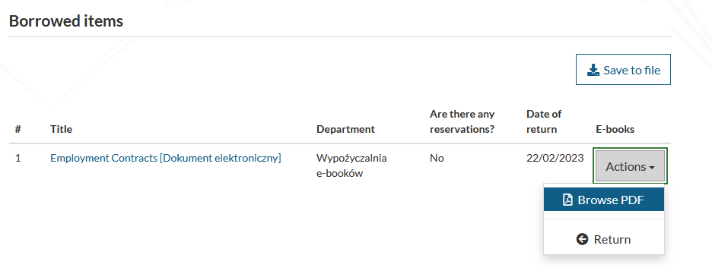
- E-books are automatically refunded after 5 days. To return the e-book before this date, use the Return button in the same place

