………………………………… Dąbrowa Górnicza, ………………
(Name)
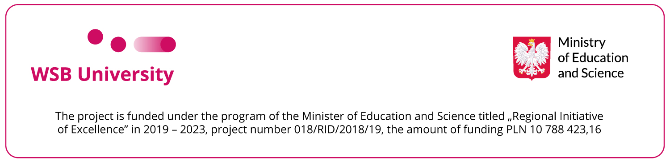
…………………………………
(academic degree, academic title, post)
…………………………………
(discipline)
…………………………………
(ORCID number)

Rector
WSB University

I kindly request to express the consent to take part in the conference entitled:
............................................................................................................................................................. along with the publication
The conference organizer:
The conference date ........................................... The conference venue:
The conference cost: ………………………………………………Means of transport:
With overnight stay: YES / NO* Accommodation cost:
At the above-mentioned conference I will present the paper entitled:

Published in:
Reason:
Type of publication:
Type of publication | YES * | number of points/quartile/SNIP or IF
Publication in indexed journals from WoS database
Publication in indexed journals from Scopus database
Publication in journals enumerated in the list „Support for Journals”
Publication in different journals, not mentioned above, found in a different database than Web of Science Please specify the database …………………….
A chapter in a monograph from the list of publishers of MNiSzW (the Ministry of Science and Higher Education)

*please mark the right type of publication with X
declarations by the applicant:
- I declare that the publication will be affiliated only with WSB University;
- I declare that the publication is accounted to the discipline of management and quality or economy and finance and may be indexed by the WSB University in evaluation of scientific activity;
- I oblige to include the following note: „Projekt finansowany w ramach programu Ministra Edukacji i Nauki pod nazwą „Regionalna Inicjatywa Doskonałości” w latach 2019 - 2022 nr projektu 018/RID/2018/19 kwota finansowania 10 788 423,16 zł” or the English equivalent: „The project is funded under the program of the Minister of Education and Science titled “Regional Initiative of Excellence” in 2019-2022, project number 018/RID/2018/19, the amount of funding PLN 10 788 423,16” and if possible the logotype of the Ministry of Education and Science (can be downloaded from www.wsb.edu.pl/rid -> downloadable documents.
..............................................
legible signature of an employee

I confirm/I do not confirm* the number of points for publications ………………………………………
signature of Science Development Department employee

Annexes to the application:
- bank transfer details i.e. full name of the institution, bank account number, transfer title, payment date, etc.
- invitation to the conference, confirmation confirmation of accepting the paper for publication, information leaflet, etc.

I hereby AGREE/ DO NOT AGREE*  to allow the applicant to take part in the conference  ....................................................................  legible signature of the Head of Department | Opinion/Substantiation of the Head of Department  ........................................................................................  ........................................................................................  ........................................................................................

Decision

I hereby AGREE/ DO NOT AGREE*  to allow the applicant to take part in the conference  Comment:…………………………………………………  ....................................................................  Date and Vice-Rector’s for Scientific Research signature | I hereby AGREE/ DO NOT AGREE*  to allow the applicant to take part in the conference  Comment:…………………………………………………  ....................................................................  Date and Chancellor’s signature | I hereby AGREE/ DO NOT AGREE*  to allow the applicant to take part in the conference  Comment: ................................................  ..................................................................  Date and RECTOR’S signature

* delete as appropriate

