INSTRUCTIONS FOR REGISTRATION OF
A NEW USER
- Go to the website: www.wsb.edu.pl/biblioteka
- In the left menu select the book mark „Katalog on-line”
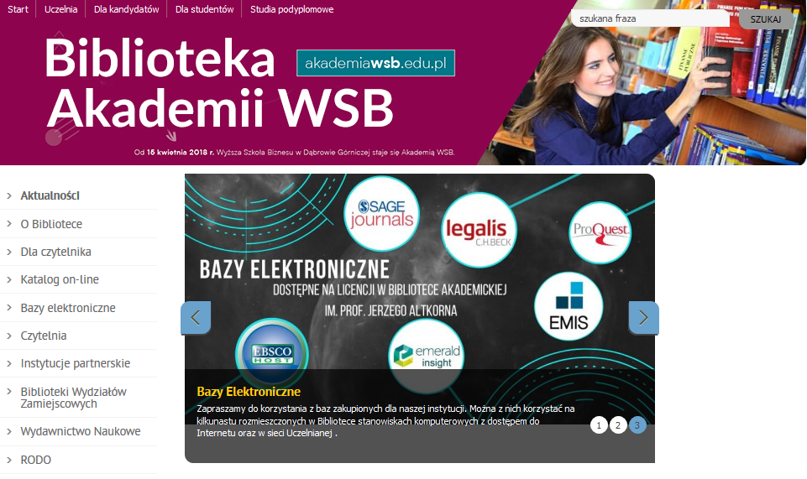
- Then click the button „Wejście do katalogu”.
- Select „Rejestracja nowych czytelników” (Registration of
a new reader) – middle icon in the upper right corner.

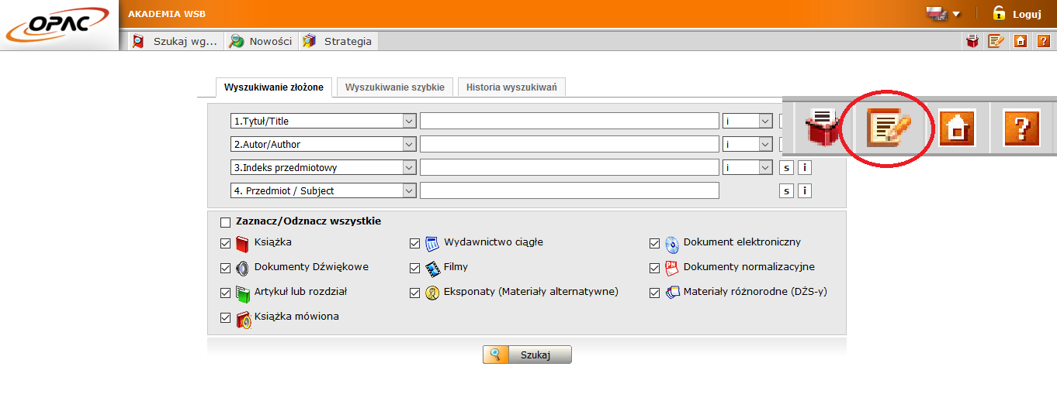
- When you get the registration form- select the English version (icon in the upper right corner).
6. Fields marked with a red asterisk are mandatory.
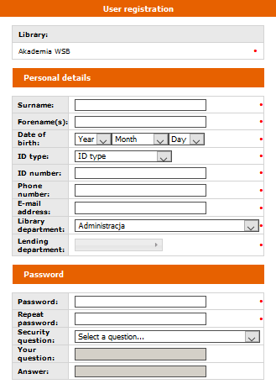
ATTENTION!!!
- Id type:
LEGITYMACJA –green student Card
- Id number:
„Numer albumu” – check on your student card.
- Library department- your subject.
- Password – not less than 3 characters and no more than 10, without Polish characters.
- ID – if the registration was correct, you should get a number.

Due to the SARS-CoV2 virus epidemic, library account activation does not require a library visit – accounts registered until 3.30 pm will be activated by library staff the same day before 4 pm. The accounts set up after 3.30 pm will be activated the next day of the library work.

