Instructions for borrowing ebooks
- You can only borrow ebooks by logging into your library account.
- In the list of search results, ebooks appear with the annotation "you can borrow online".
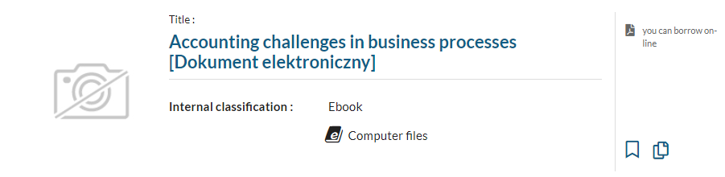
3. To borrow the ebook of your choice, select the title and then click Borrow on-line.
- The system will automatically take you to the "Borrowed items" section. There you will find your borrowed ebooks. To use, click Actions, then Browse PDF.
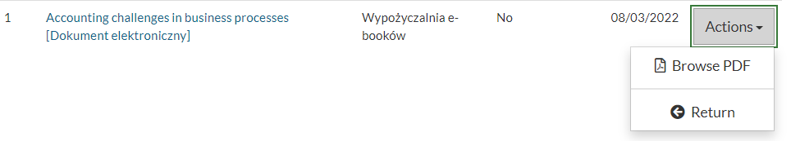
- The ebooks are returned automatically. To return an ebook before this date, use the Return button in the same place.

