INSTRUCTIONS FOR REGISTRATION OF
A NEW USER
- Go to the website: www.wsb.edu.pl/biblioteka
- In the left menu select the book mark „Katalog on-line/On-line Catalog”,
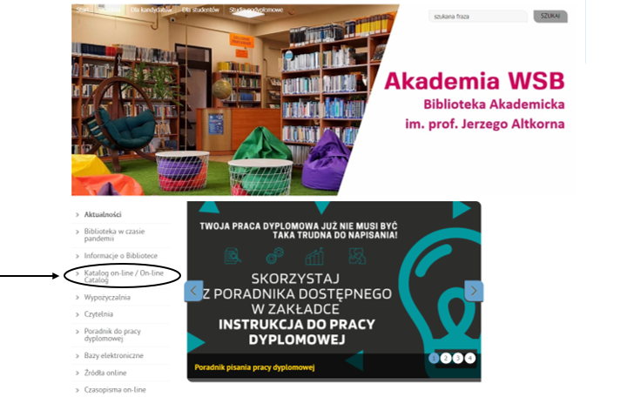
- On the top of website select „Polski” and change language.
- Choose Profile then Sign Up – middle icon in the upper right corner.

5. Fill all fields, fields marked with a red frame are mandatory. In library department choose Stosunki Międzynarodowe. Lending department should be same as city where you are studying.
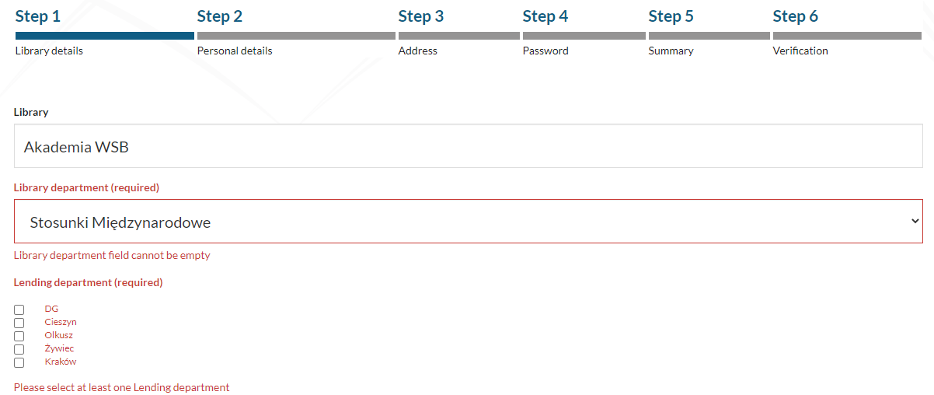
- In next step fill all required fields.
Id type: Legitymacja - green student card.
Id number: Numer albumu – check on your student card.
Step 3 requires you to enter your home address (you can also provide an alternative address)
In step 4, set a password as required.
Then check and confirm the entered data in the next step.
Enter the code from the picture and give your consent.

The ID is your LOGIN for the library catalog,
therefore it should be kept.
After registration, the account will be locked.
Within 2 working days, the Library employee will verify
and activate your account.

