INSTRUCTIONS FOR ORDERING BOOKS
- Go to the website: www.wsb.edu.pl/biblioteka
- In the left menu select the bookmark „Katalog on-line /
On-line catalog”.
- Select the English version (in the upper right corner).
- In the upper right corner choose Profile, then Log in and input your ID and password.
- Search in main window book, which you are interested in. You could search by title, author or topic.
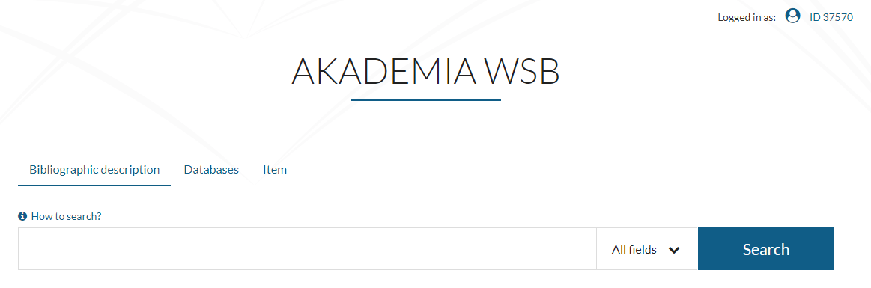
- Choose title from the list. If book is loanable and available, click “Request”. Requests going to your Requests cart.
- If item is available on-site only, mean that you can use it in reading room.
- Repeat steps 5-6 with all books which you want order. In window choose Continue browsing. When you have all needed books in cart choose Go to the request cart.
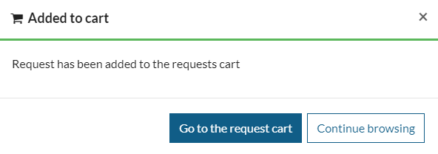
- Accept your your order by the button „Confirm request”.
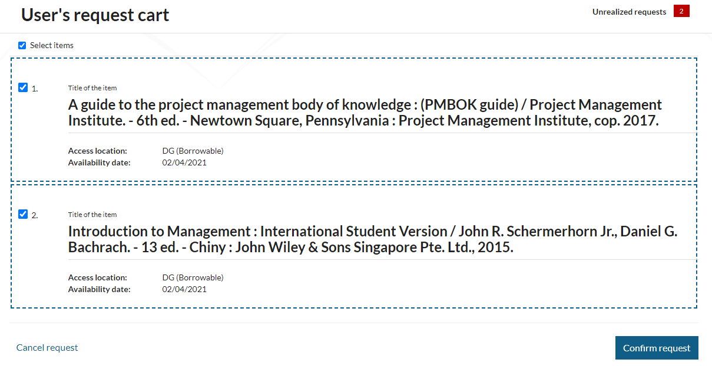
ATTENTION! Skip step „Confirm request” make that order doesn’t arrive to library system.
- The book must be picked up in 3 days.
After this time, the system will automatically cancels the ordered books.
- Ordered books are ready to take in 15-45 minutes.

INSTRUCTIONS FOR RENEWING BOOK
- Repeat steps 1-4 by Instruction for ordering books.
- Select ID XXXXX in right upper corner.
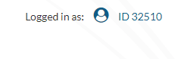
- Select bookmark „Renewable items”
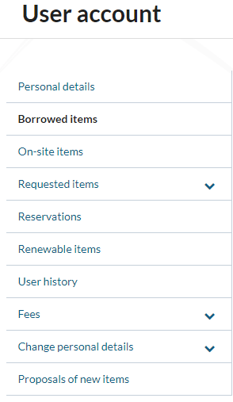
- Then select items that you want to renew and accept by “Renew”.
ATTENTION! You can’t renew books if:
- time for return has been exceeded,
- item has been reserved,
- limit for renew has been exceeded.

INSTRUCTIONS FOR RESERVING BOOK

- Repeat steps 1-4 by Instruction for ordering books.
- Search in catalog book, which you are interested in. If item is lent by other student, click button Book, then Any items.
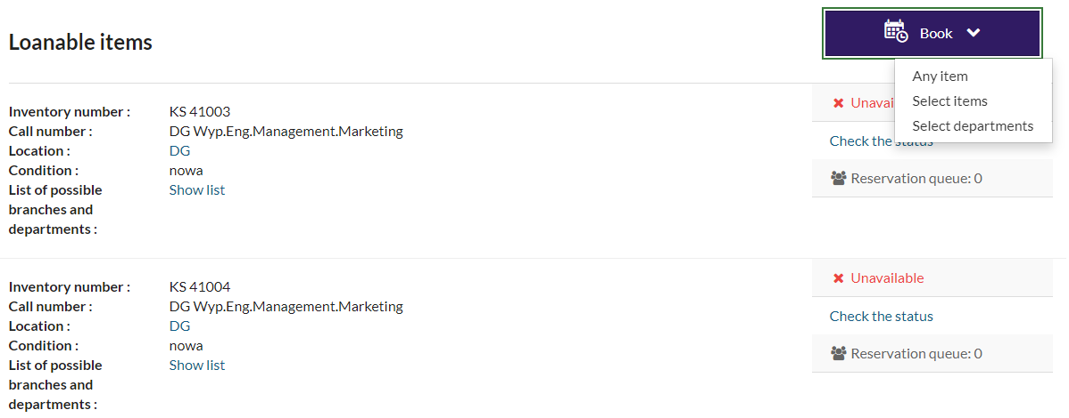

- Reservation queue inform you how many people before you reserved this book and in which order you are.
- Accept expiry date of reservation by Confirm.
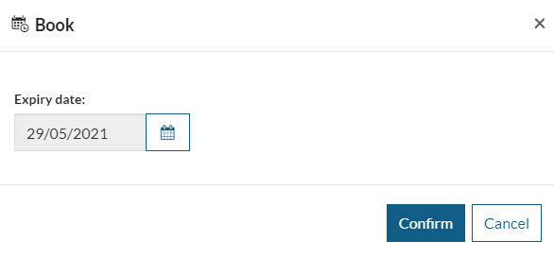
- When book will be returned, system will inform you by e-mail.
- The book must be picked up in 3 days.

