e.g. Jan Kowalski
First name and surname

e.g. 12345
Register number

e.g. Management
Field

e.g. International Business
Specialization

Mode: Full-time
use a black font

STATEMENT

Aware of my responsibility, I hereby declare that the Bachelor’s/ Engineering /Master’s thesis submitted titled:

…………………………………………………………………………………………….
was entirely written by myself.

I also declare that the above the work does not violate copyright within the meaning of the Act of 4 February 1994 on Copyright and Related Rights (Journal of Laws No. 24, item 83 as amended) and personal rights protected by civil law.

The aforementioned thesis does not contain data and information that I obtained in a prohibited way. This diploma thesis has not previously been the basis of any other official procedure related to the awarding of university diplomas or professional titles.

I declare that I grant WSB University free rights to enter and process my diploma thesis in the anti-plagiarism system.

Dąbrowa Górnicza, date:......................................... ...........................................................
Signature

Faculty of Applied Sciences

Field of study e.g. Management

BA / MA THESIS

Name

Title

BA / MA THESIS
written under the supervision of
………………………………………
in format: title first name surname

Approved …………………………………………
Date and supervisor’s signature

Dąbrowa Górnicza 2022

TABLE OF CONTENTS

INTRODUCTION 5
CHAPTER I
………………….. 7
1.1. . 8
1.2. 11
1.3. 16
CHAPTER II
20
2.1. 20
2.2. 23
2.2.1. 25
2.2.2. 27
2.2.3. 31
CHAPTER III
34
3.1. 34
3.2. 36
3.3. 39
CONCLUSIONS 43
REFERENCES 45
LIST OF TABLES 49
LIST OF FIGURES 49
ANNEX 51

Volume of pages; from 1 chapter up to and including conclusions:
I cycle - minimum 45 pages
II cycle - minimum 70 pages

Always the 3rd page

INTRODUCTION

Always the odd page

CHAPTER I
MARKETING STRATEGY IN THE LITERATURE

  - Marketing strategy definition

Always the odd page

CHAPTER II
CHARACTERISTICS OF SPACEX
Always a new page (it does not matter on which page - the odd or even one)

  - Profile of SpaceX

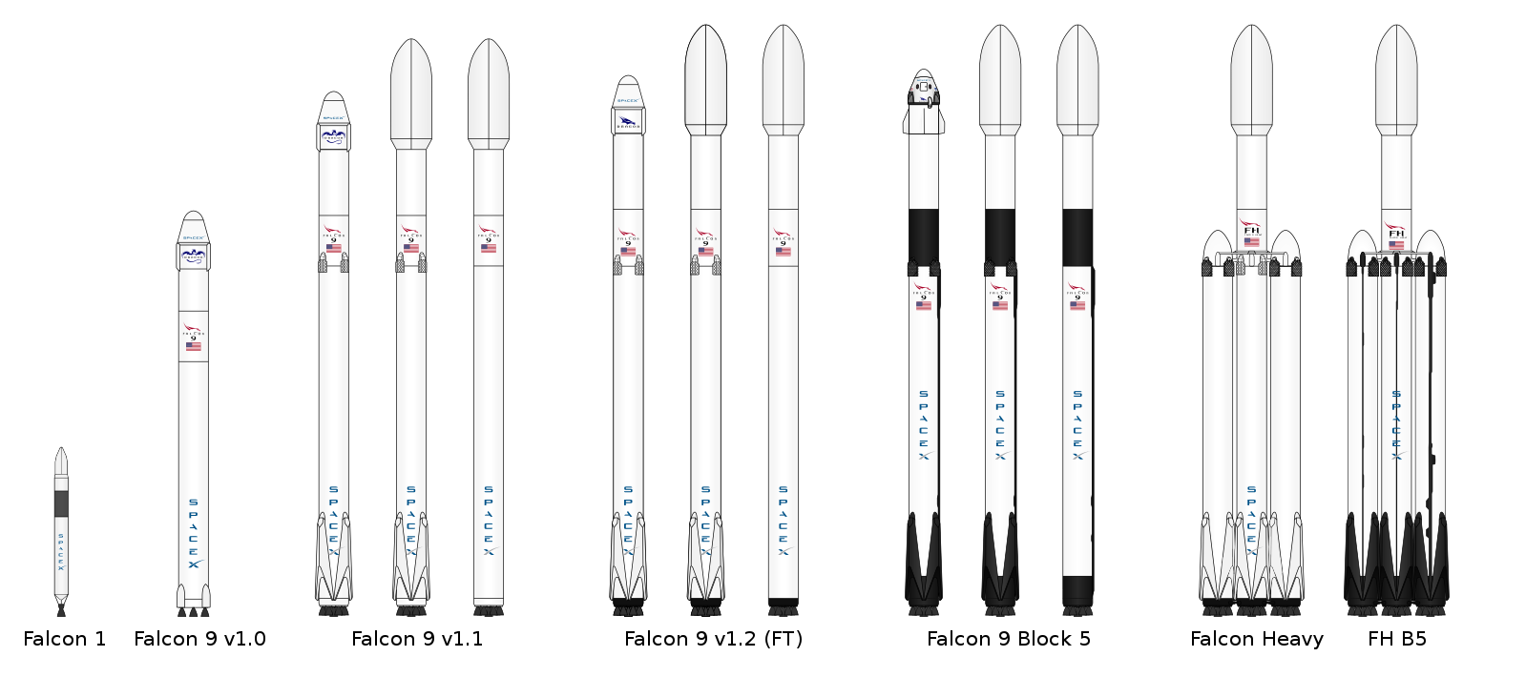
Figure 1. Falcon rocket family
Source: https://commons.wikimedia.org/wiki/File:Falcon_rocket_family6.svg

Table 1. SWOT analysis
Strengths | Weaknesses
- Reusable rocket system.  - Position in the launching market.  - In-house development.  - Decision independence.  - Competitive pricing.  - IP and innovation.  - Vision.  - Social media presence. | - Profitability dependence.  - Failure record.  - Low launch frequency.  - High investments.  - Company at initial state.  - Limited budget.
Opportunities | Threats
- Market growth potential.  - Potential NASA contracts.  - Partnerships.  - Space tourism.  - Low number of competitors. | - New entrants.  - Contract dependence.  - Cost of factors of production.  - New technologies and R&D.  - Weak enterprise profitability.  - Regulations.
Source: author's own criteria
Remember to always add the source

    - Pestle Analysis

The PESTLE analysis is based on a macroeconomic description of a business’s environment, taking into account the following macroeconomic factors: political, economic, sociocultural, technological, environmental, and legal (i.e., business climate).

remember footnotes (in the following format, not footnotes in brackets)

Economic factors:
- Budget allocation during critical socio-economic situations, fields other than space activity are prioritized.
- Effects of global recession, not only in America but around the world.
- Economic effects of the Russo-Ukrainian war.
- Budget cuts on NASA, this budget has increased nominally over the past 50 years, although decreasing gradually as a percentage of the federal budget.
- Employment rate.
- Inflation rate.
- Trade barriers.
Social factors:
- Support from the American government. Historically, space travel has been led by the US since the cold war.
- Public acknowledges and embraces SpaceX achievements.
- Collective curiosity to explore beyond the limits of our reach into the unknown.
- Corporate social responsibility culture.
- Impact of both conventional and social media.
Technological factors:
- High dependence on research and development.
- Development of more efficient aeroespacial technology.
- Property rights & protection of technological assets.
- Artificial Intelligence development.
- Automation.
Legal factors:
- Failed missions would hold SpaceX liable, like the Challenger’s disaster in 1986 hurt NASA’s reputation.
- Manipulation or modification of the Outer Space Treaty, for example, article VI holds international responsibility for national actions in outer space, including the moon and other celestial bodies, whether conducted by government agencies or private enterprises.
- The Commercial Space Launch Competitiveness Act of 2015 gives the ability for both private and commercial companies to explore space.
- Intellectual property rights protection.
- Health & Safety law.
- Regulatory compliance.

Not:
- > * or other signs

page numbers on the outside
CONCLUSIONS

Always the odd page

REFERENCES
Always the odd page

- Armstrong G., Marketing: An Introduction, Pearson Education, [n.p.] 2009.
- Baker M., Hart S., The marketing book, Butterworth-Heinemann, ed. 5, [n.p.] 2003.
- Burnett J., Introducing Marketing, The Global Text Project, [n.p.] 2010, p. 169.
- Cancel D., Gerhardt D., Conversational marketing, John Wiley & Sons, ed. 1, Hoboken 2019.
- Dodson I., The art of digital marketing. John Wiley & Sons, [n.p.] 2016, ed. 1
- Drucket P., Managing in Turbulent Times, Harper & Row, New York 1980.
- Ferrell O., Hartline M., Estrategia de marketing, Cengage Learning, [n.p.] 2012,
- Florida R., The world is spiky, The Atlantic Monthly, [n.p.] 2005.
- Friedman T., The world is flat: A brief history of the twenty-first century, Macmillan, London 2006.
- Halligan B., Shah D., Inbound marketing, John Wiley & Sons, New Jersey 2010.

Surname first, without pages, ending with dot

LIST OF INTERNET RESOURCES
- https://www.ama.org/listings/2013/01/17/definition-of-marketing/#:~:text=%E2%80%9CMarketing%20is%20the%20activity%2C%20set,%2C%20and%20society%20at%20large.%E2%80%9D
- https://adage.com/article/agency-viewpoint/a-word-advertising-exist/303678

LIST OF TABLES
Always the odd page
Table 1. SWOT analysis 27
Table 2. PESTLE analysis 30
Table 3: Price chart 38

LIST OF FIGURES

Figure 1. Falcon rocket family 23
Figure 2. Visual representation of Porter’s Five Forces 31

ANNEX

If you have any
Always the odd page

J. Tanner, M. Raymond, Principles of Marketing, Flat World Knowledge, vol. 2, [n.p.] 2013, p. 555.
https://en.wikipedia.org/wiki/Budget_of_NASA
https://www.nasa.gov/feature/35-years-ago-remembering-challenger-and-her-crew
https://www.unoosa.org/oosa/en/ourwork/spacelaw/treaties/outerspacetreaty.html

