Academic Career Office
User’s Instructions – Student

History of the document
Document version no. | Date of modification | Published by | Description of the modification
1.0 | 03.01.2022 | Krzysztof Tomaka | Creating the document template
2.0 | 01.06.2022 | Krzysztof Tomaka | Updated
3.0 | 13.10.2022 | Krzysztof Tomaka | Update of the cv edition

Introduction 5
Home page 5
Logging in 5
Registration 6
Toolbox 7
Desktop 9
Messages 11
Contact 11
Catalogue of offers 13
Search engine 13
Observed results 15
My applications 16
Favourite 16
Invitations 17
CV 17
Edit 17
My CV 19
Events 21
Surveys 24
News 25

Introduction
The Academic Career Office is an application aimed at supporting communication between potential employees (students, graduates) and employers. The system has been designed in a way that enables the exchange of information and expanding the competences by registering for relevant events. Application users are students and employers looking for or offering a job. The students prepare their CVs, where they outline their own education and experience, then apply for jobs offered by the employers. The system is managed by employees of the Career Office who help students and employers.

Home page
The page displayed after selecting the website address.
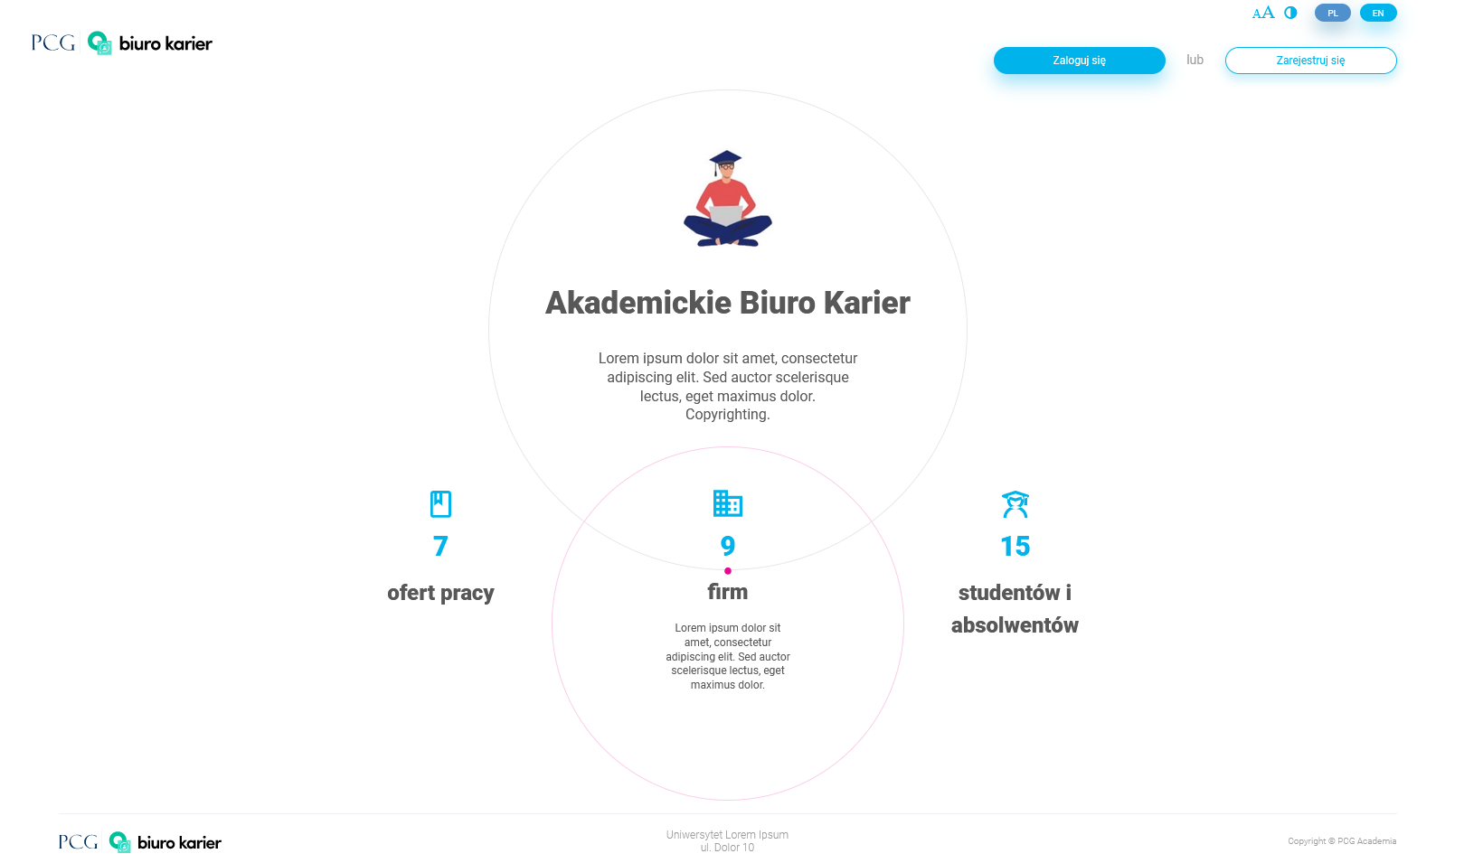

Logging in
Using the system's functions requires prior logging in. Students who have an account in the university system choose Zaloguj w systemie uczelnianym-> Domena uczelniana (Log in the university system -> University domain). Users enter their login and password in the fields provided for this purpose. It is possible to save the password and the login details; this function is recommended for use on trusted devices.
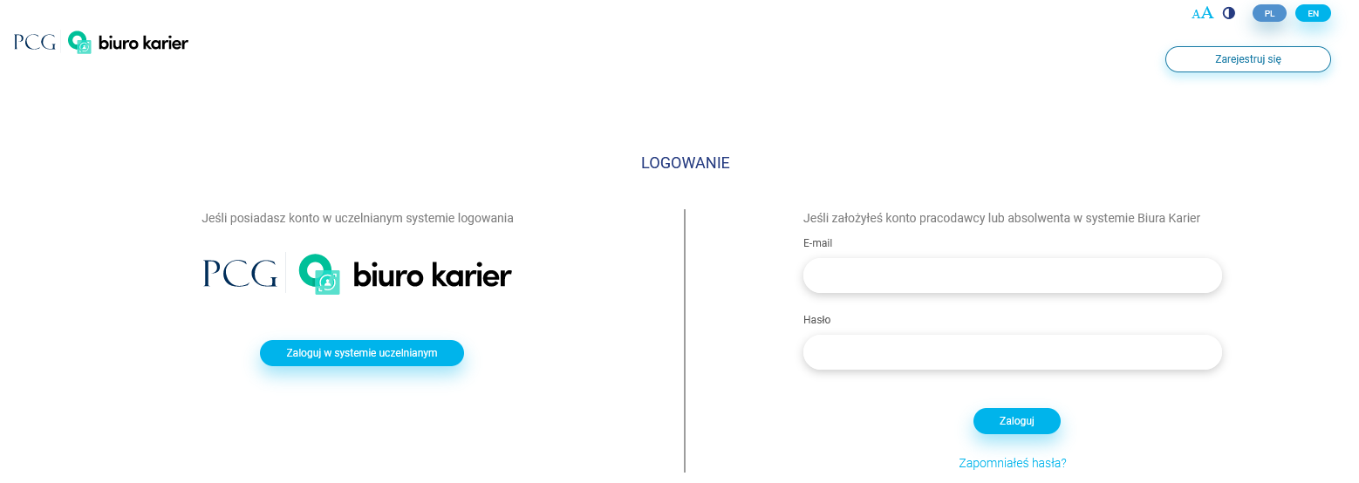
During the first login through an account in the university system, you may be asked to mark the consents that are required to use the system.
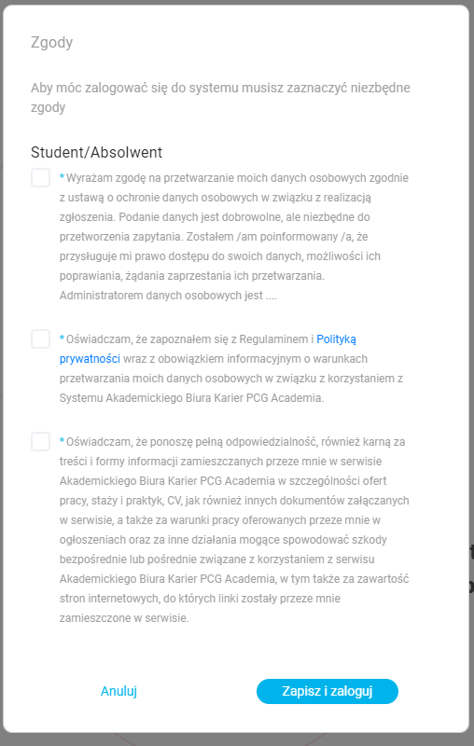
Mark at least the required consents and select the Zapisz i zaloguj (Save and login) button.

Registration
University graduates who do not have an account in the university system select Zarejestruj się (Register), then in the Rola (Role) field select Absolwent (Graduate) and complete the rest of the form.
After this operation, the system requires opening an e-mail sent to the provided address and activating it via the link in the message.

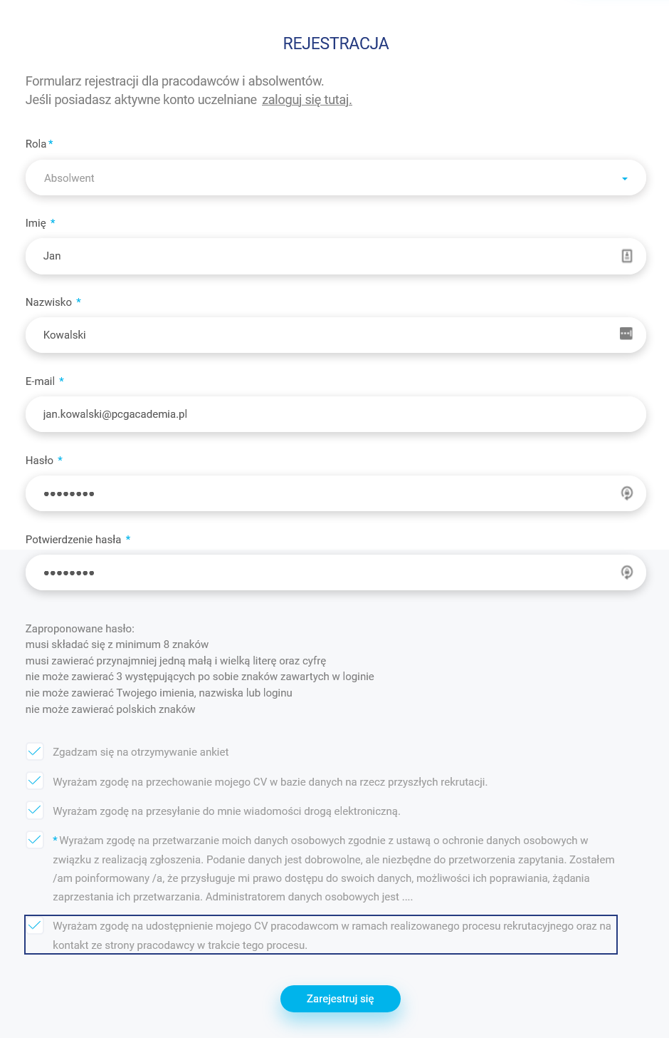

Toolbox
A toolbox, which is available at each website level, contains the following functions:
- The "AA" button allows the change of the font size, allowing the user to adjust the size of the content on each device.
- The contrast change button allows the user to set a dark theme.
- The "PL" and "ENG" buttons are used to switch between the Polish and English versions of the website.

Logged in users of the website, under the toolbox buttons, have access to a bar with a profile thumbnail and notifications:
- Name and surname / name of the account
- The envelope icon, which, when clicked, will show the latest messages (orange dot means new unread messages)
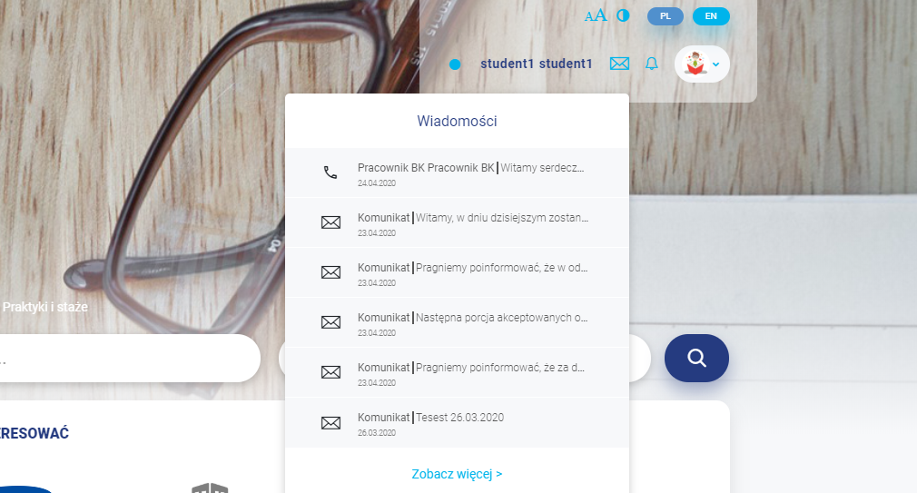

- When clicked, the bell icon shows recent notifications that may be important to the user (orange dot means new notifications that have not yet been displayed)
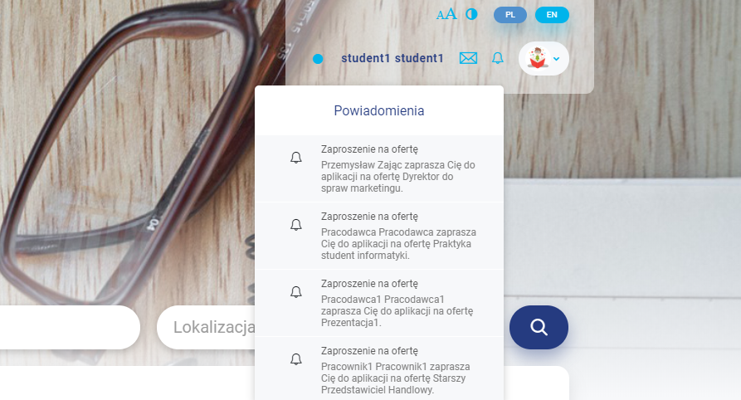
- After clicking the User icon with an avatar thumbnail, the user can go to the logout option.

Desktop
The place where the user goes by default after logging. A summary of the most important information is available here, such as: the latest job offers, upcoming events, surveys to be completed or popular searches.

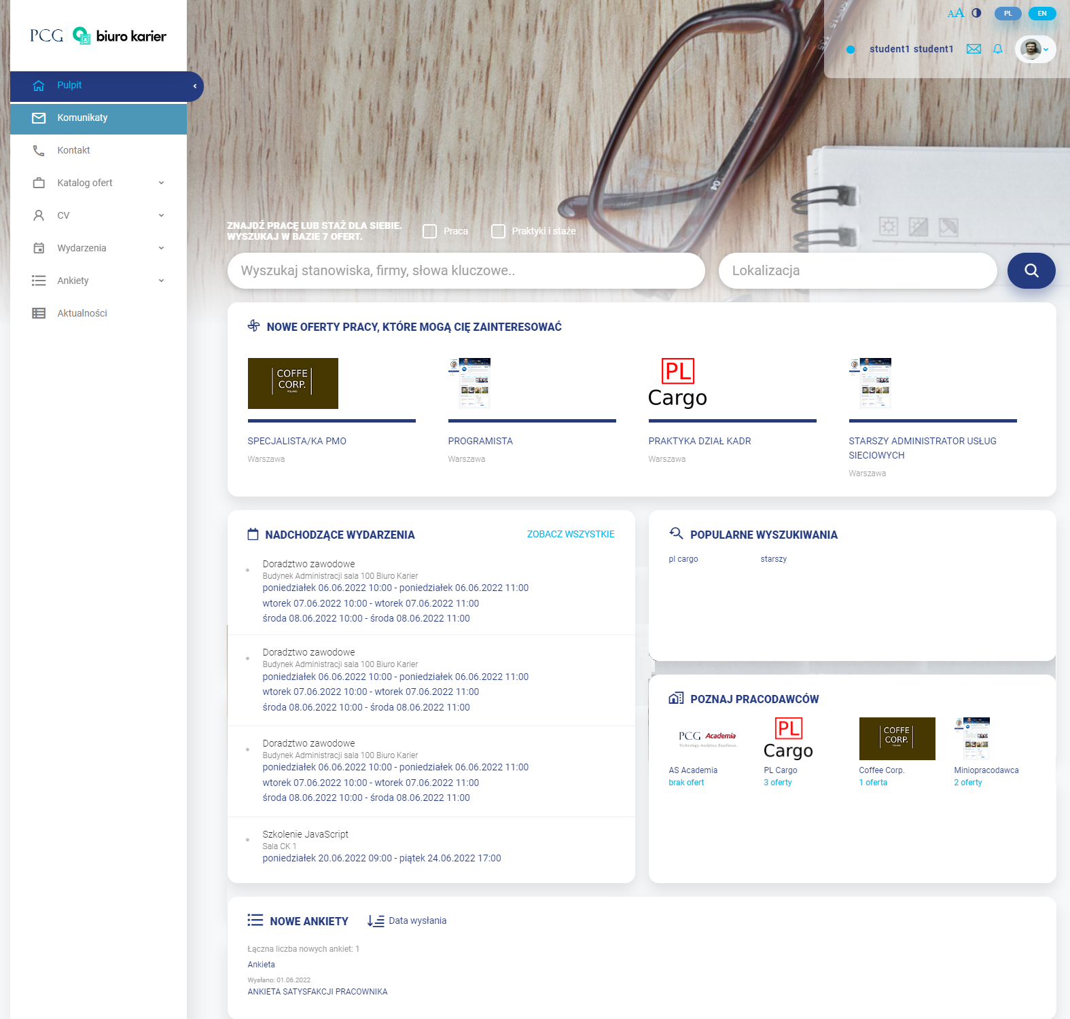

Messages
Messages received from employees of the career office are displayed here.

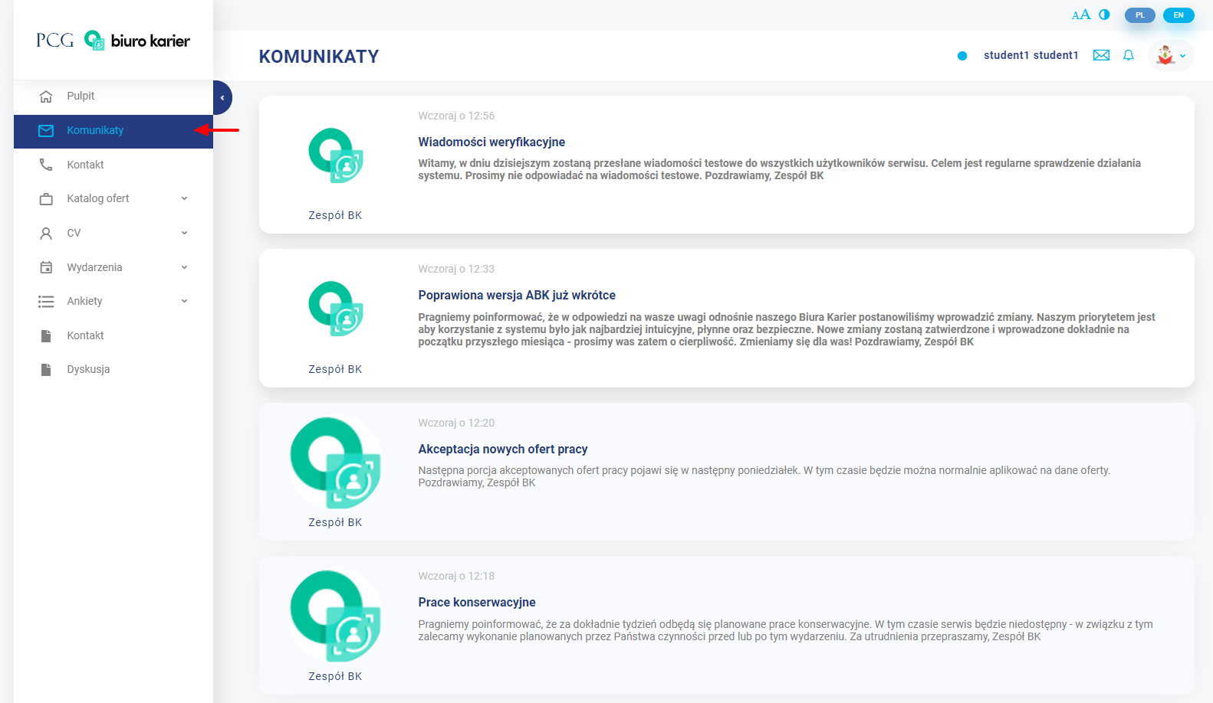
The background of already read messages is darker and the icon is larger to clearly differentiate them.
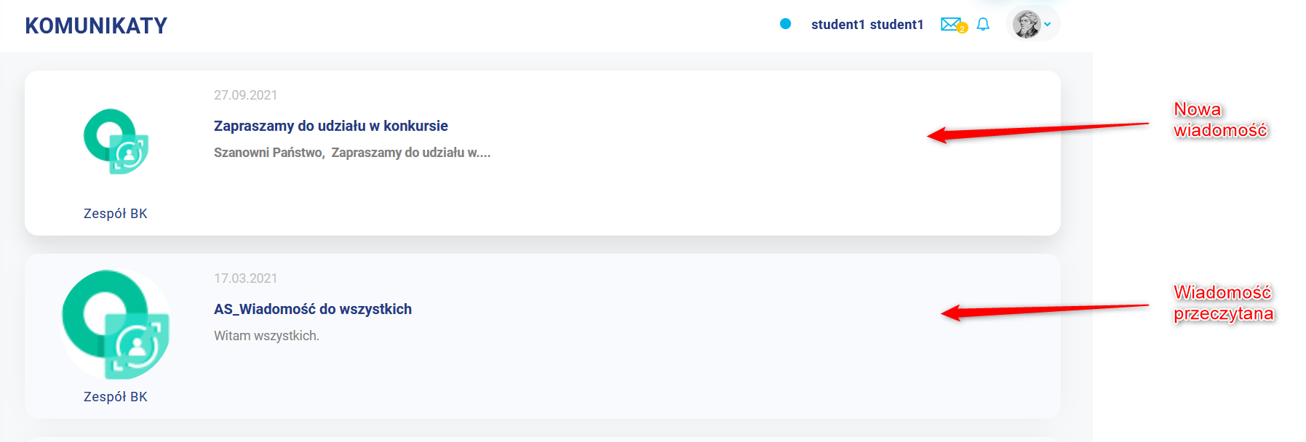

Contact
The panel for sending messages whose recipient will be an employee of the Career Office. To send a message, the user enters its title and content, and then clicks the “ Wyślij” ("Send") button. Below you can see a list with already sent records - a given record is opened by clicking on it.
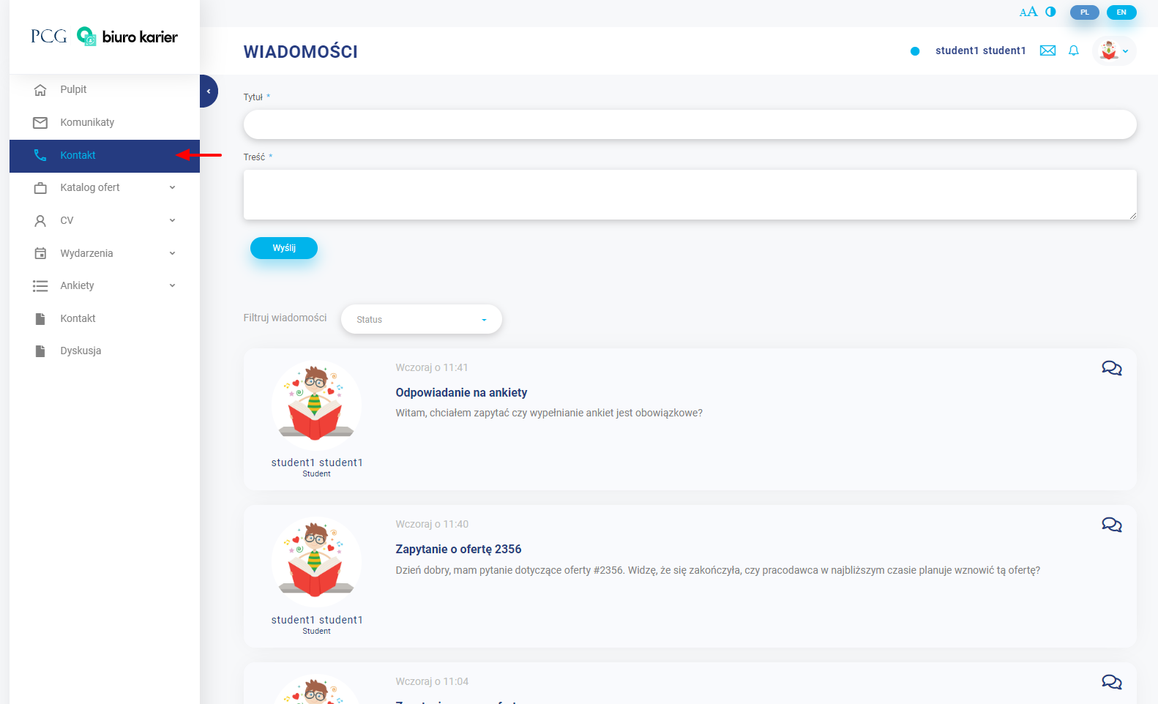

The list of messages can be limited by selecting (unread/read/all) in the Filtruj wiadomości (Filter messages) field.
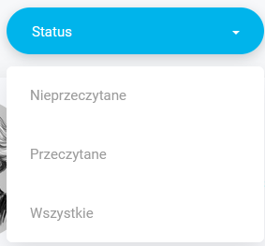
A given record is opened by clicking on an item in the list of messages.
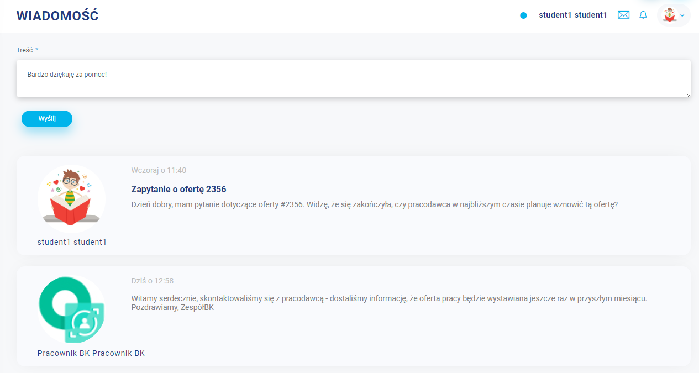

Catalogue of offers
It contains tabs related to browsing offers, saving interesting offers and applying for offers.

Search engine
Job offers are listed here. The results can be filtered and sorted, which will cause the changes to the returned list of offers.
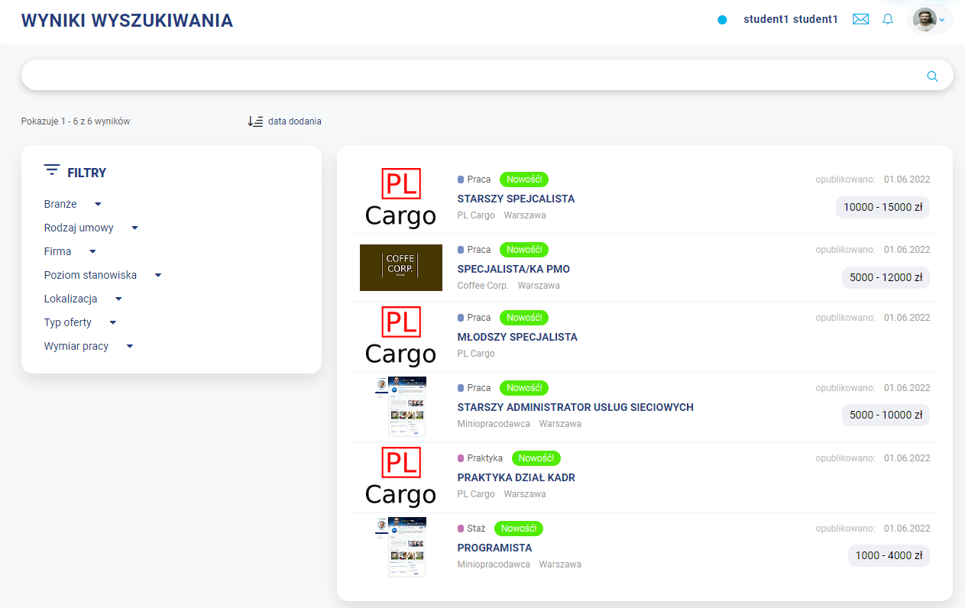
The filtered selections can be saved and added to the observed searches. New job offers that may be of interest to the user are presented as a maximum of the four most recent job offers.
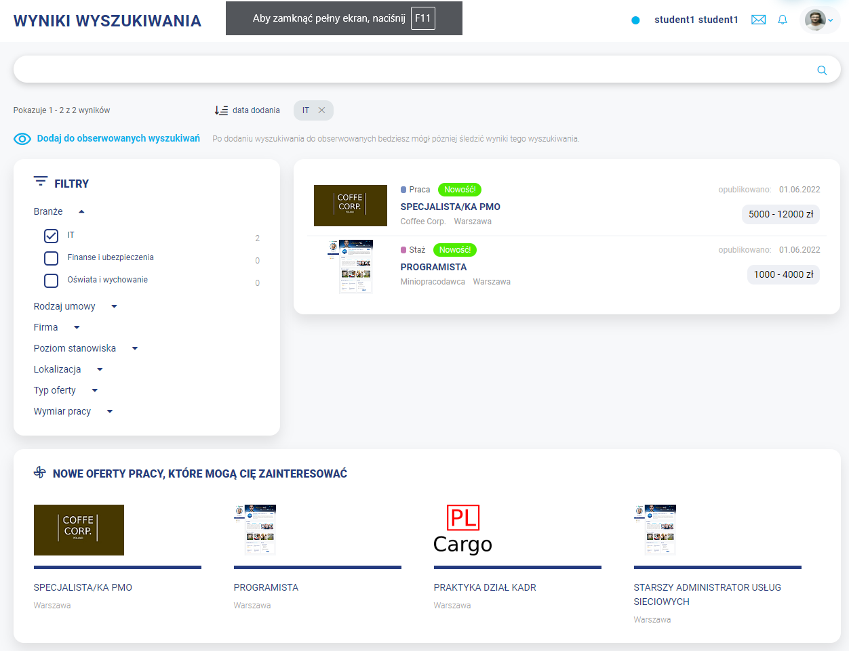

Observed results
In this tab, the user can browse and delete the search configurations of offers previously added to the observed ones.

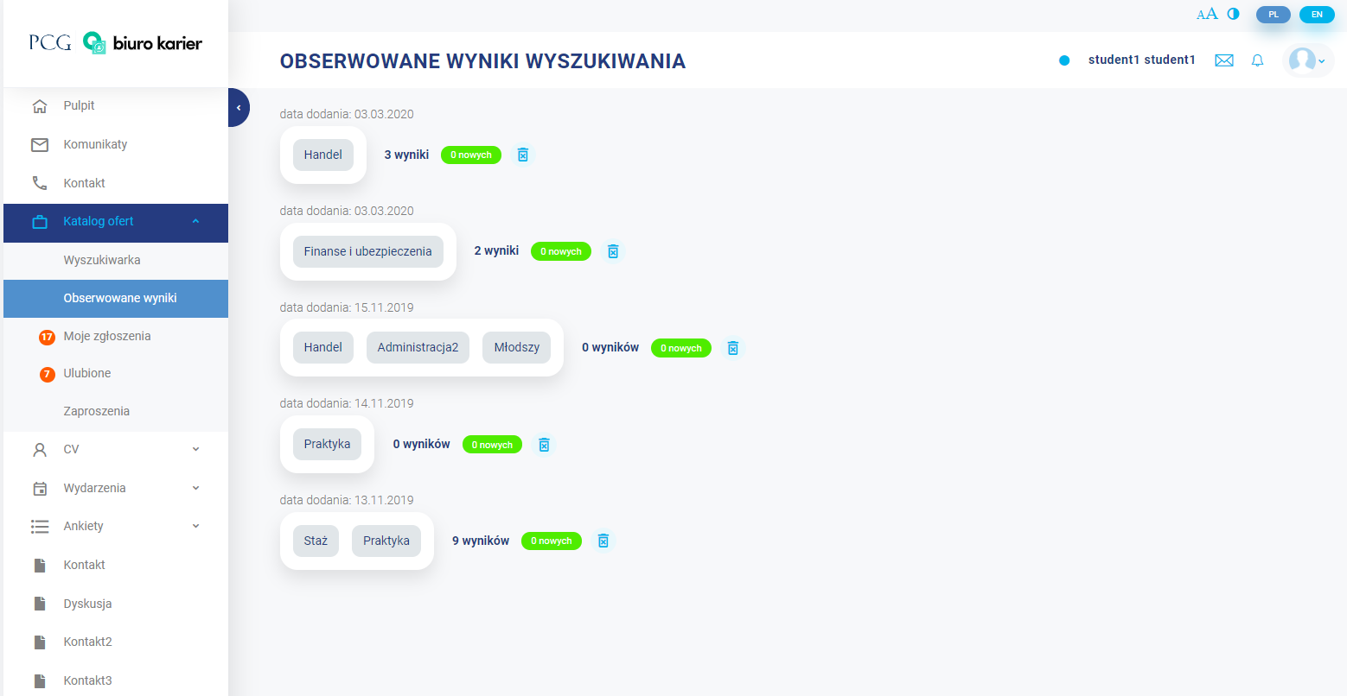

My applications
This is a list where the user can find the offers for which he or she has applied.
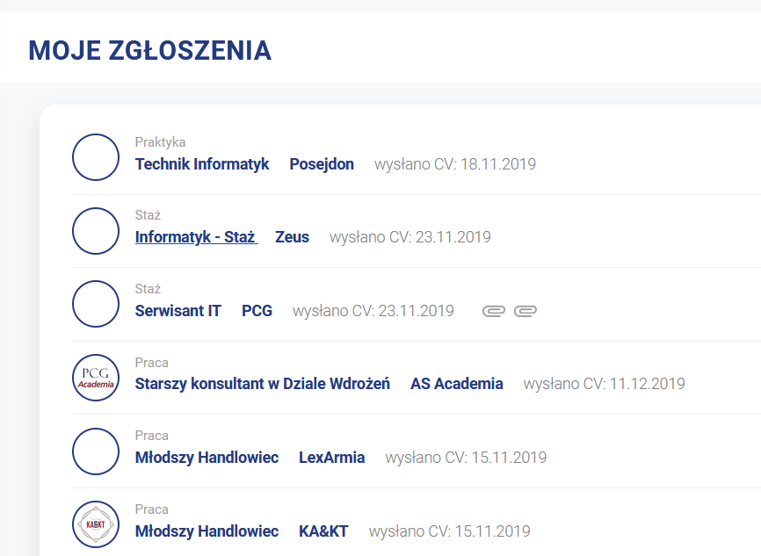

Favourite
This is a list of offers added to the list of the observed ones.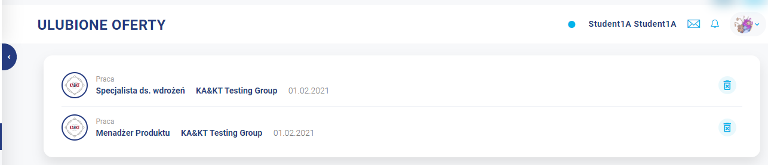

Invitations
The list of invitations allows the user to view current, archived (those that have already ended) or all offers to which he or she has been invited. They can be freely browsed and applied for here.
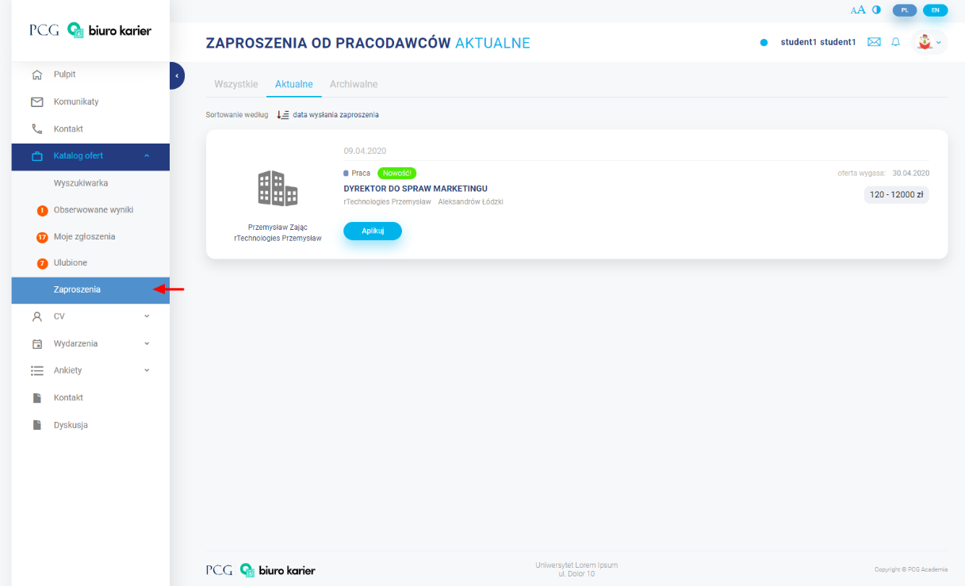

CV
Contains tabs related to the student profile.

Edit
Part intended for editing the student's CV. The following data is filled in here: basic information about the student, information about education, experience, training, courses, certificates, skills, competences, interests, and hobbies. It is particularly important to correctly complete the possessed competences - based on them, the system can connect the candidate with a given offer.

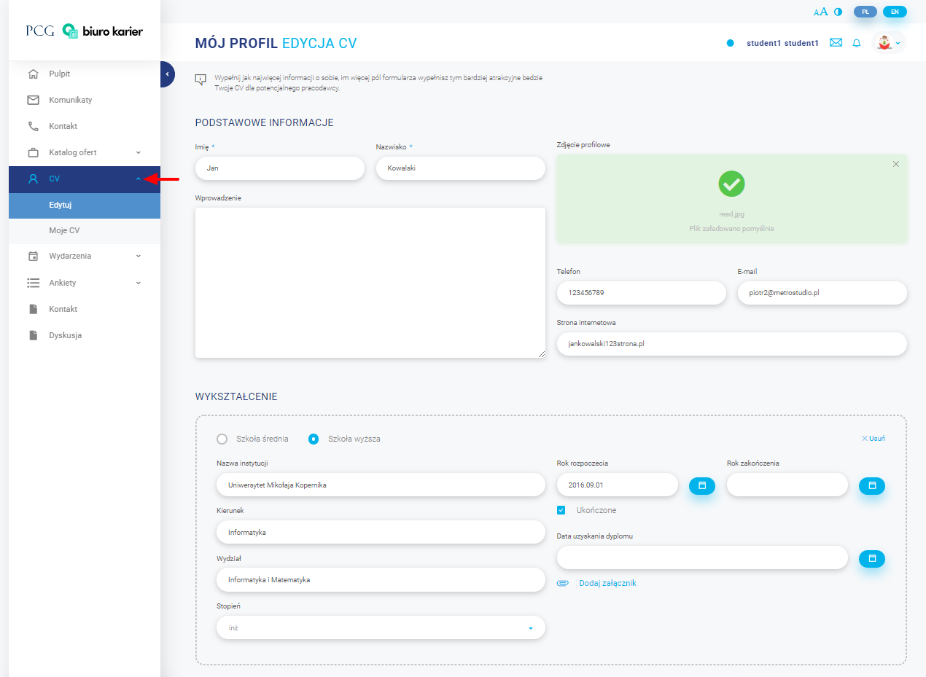
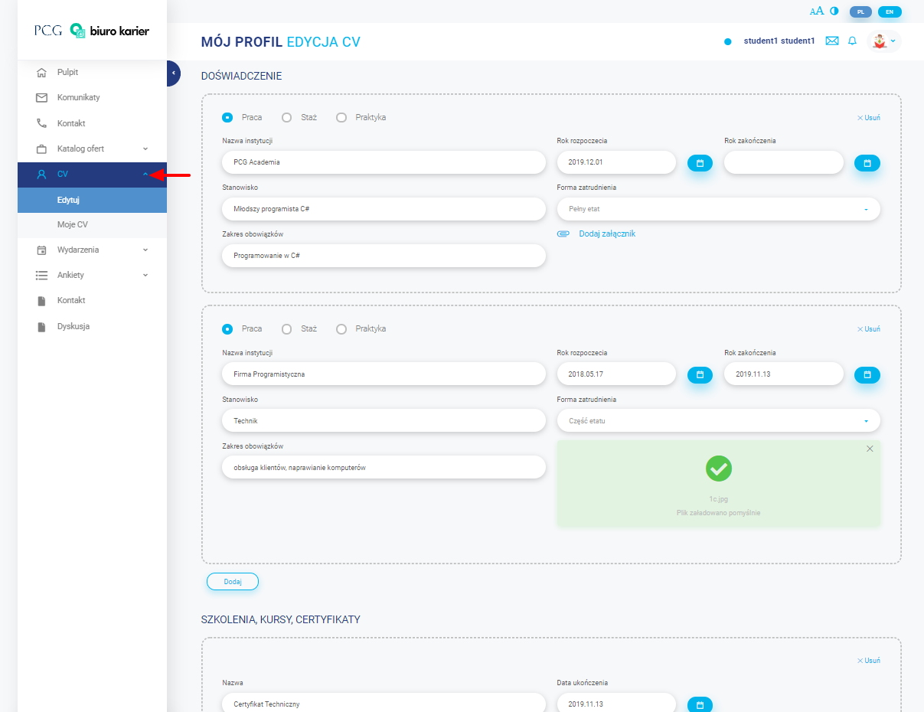
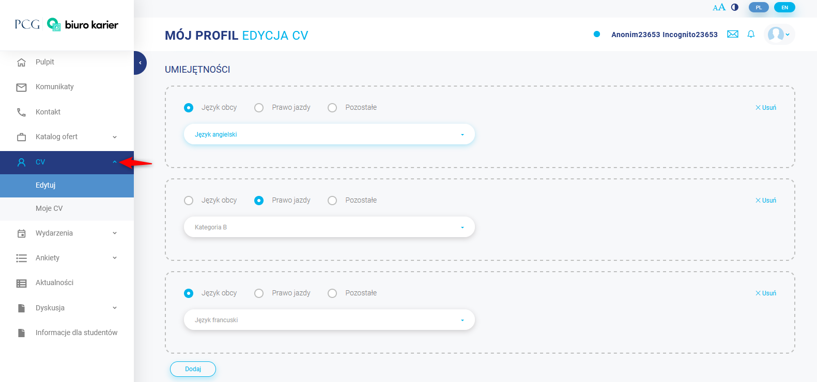
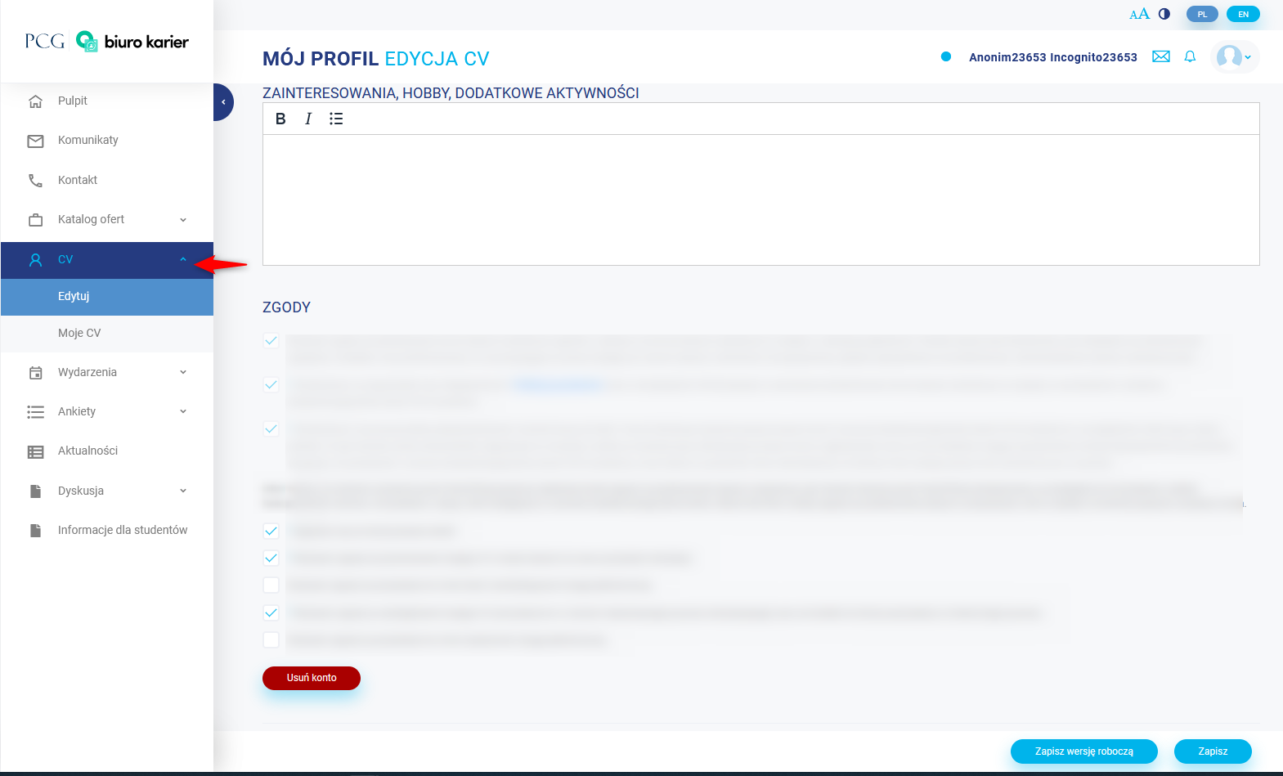
At the bottom of the CV edition, there are consents (provided during registration) and there may be additional consents, e.g. for sending a newsletter, for receiving surveys. Some consents are required to use the website, and some are optional. This part also includes the option of the deletion of an account. The deletion is preceded by a message, which involves deleting the account and the inability to use the website.

My CV
This section is intended for previewing the student's CV. Information uploaded here will also be seen by a potential employer if a student applies for a given offer. Some of the competences come directly from the education path, some result from training, while others are introduced by the user himself or herself, this is important because job offers are assigned based on competencies.

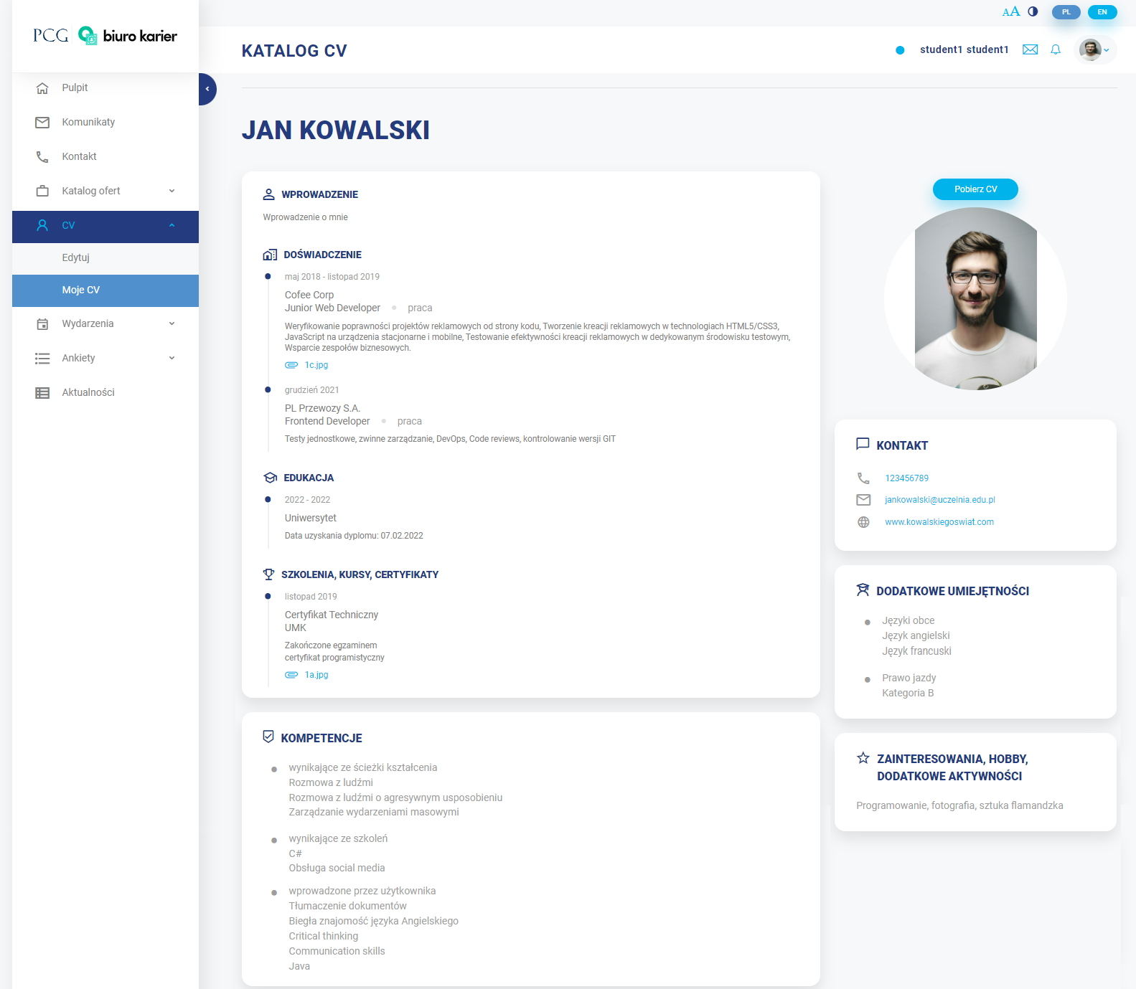
It is possible to download the CV in the form of a PDF file using the button Pobierz CV (Download CV).
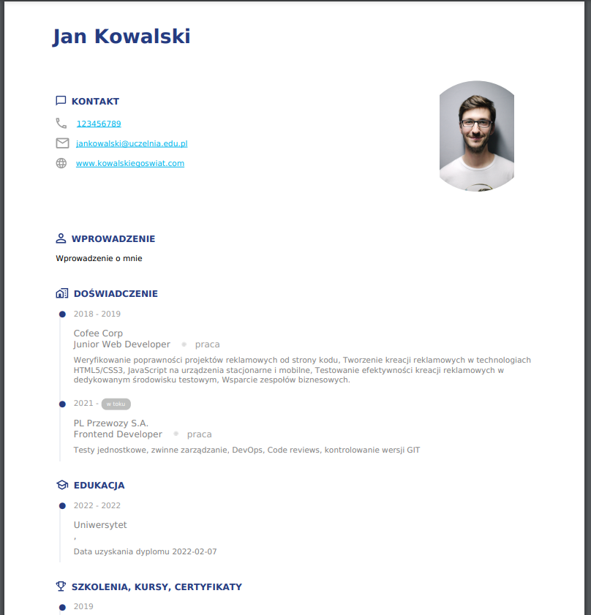

Events
Events are special offers that are not job offers. They help in acquiring new competences and skills. The events are organised by employers or the Academic Career Office.

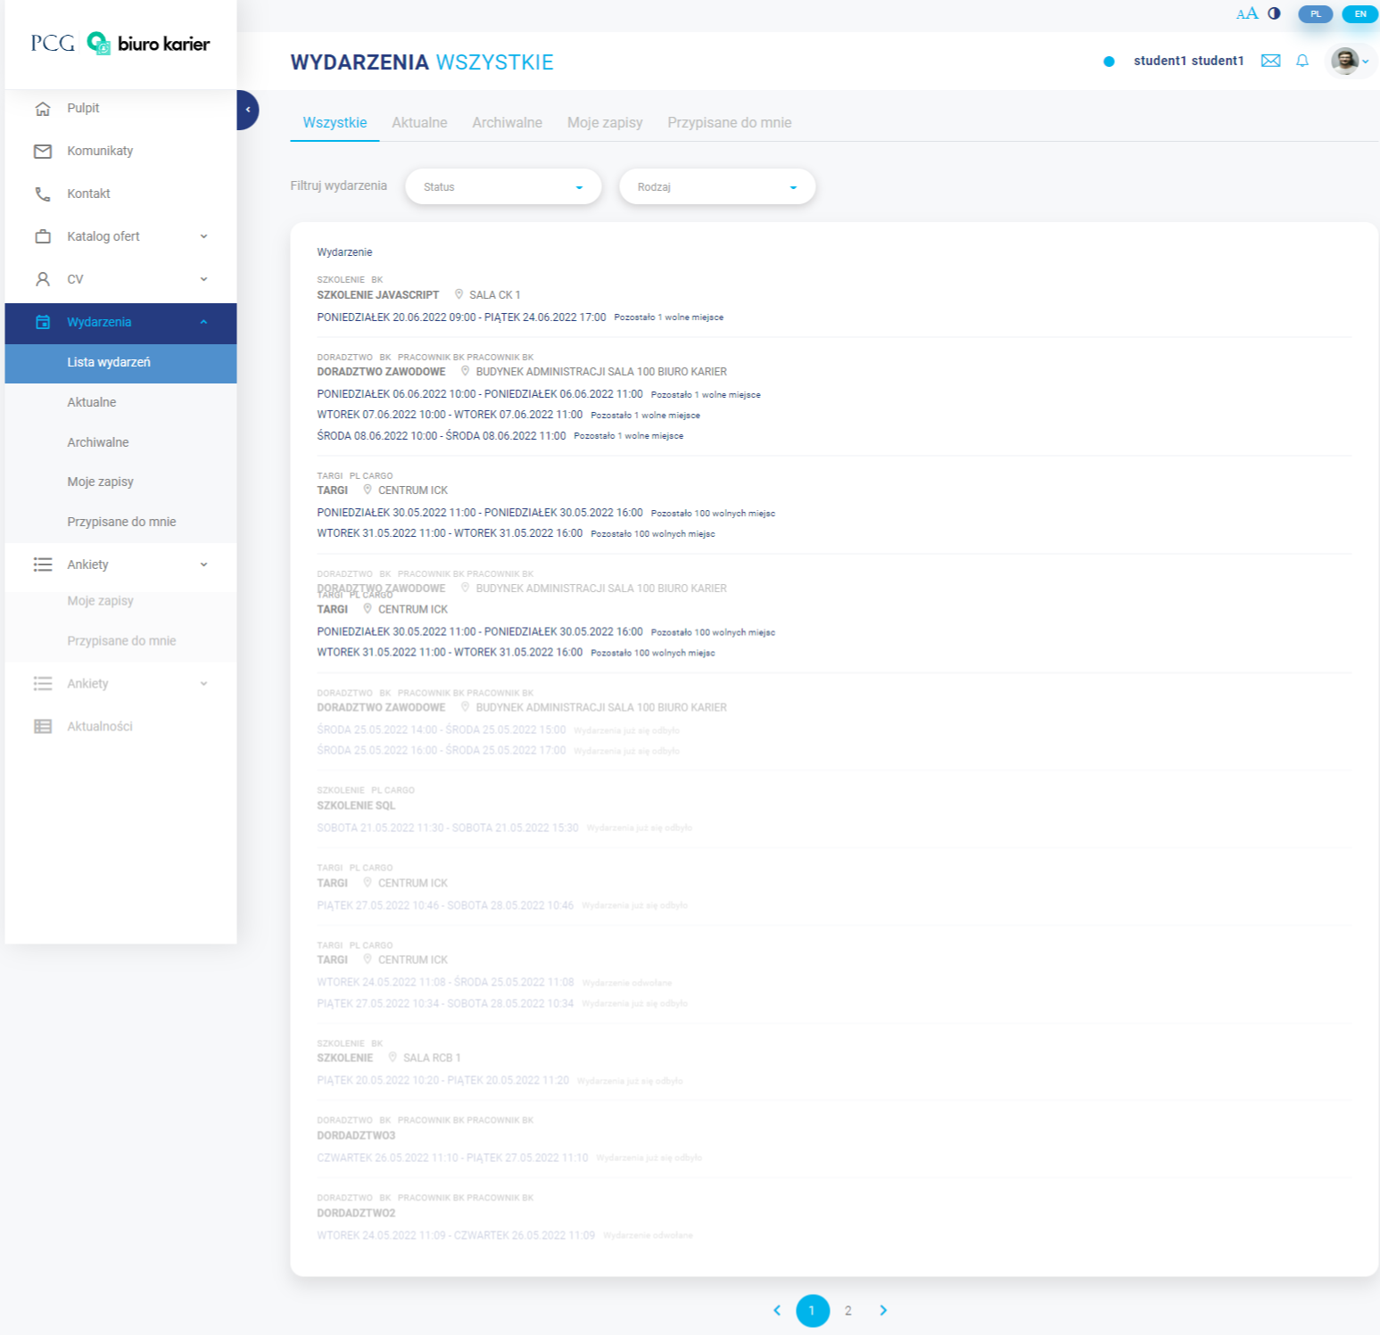
In the Events section, there are:
- Lists of events – list of all the shared events,
- Current events – list of only current events,
- Archived events – list of only archived events,
- My records - a list of events in which the user wants to participate,
- Assigned to me – a list of events that have been associated with the user if he or she has at least 50% of competencies in common with the event, there is also numerical information showing the number of matching competencies.

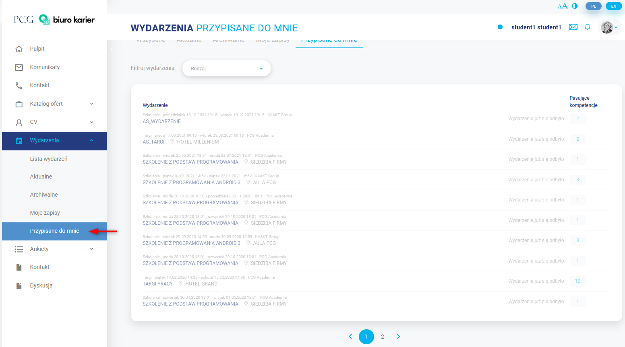
An example of an event is shown below. To register, the user selects the “Zapisz się” ("Subscribe") button in the upper right corner, then confirms his or her decision in the pop-up window.
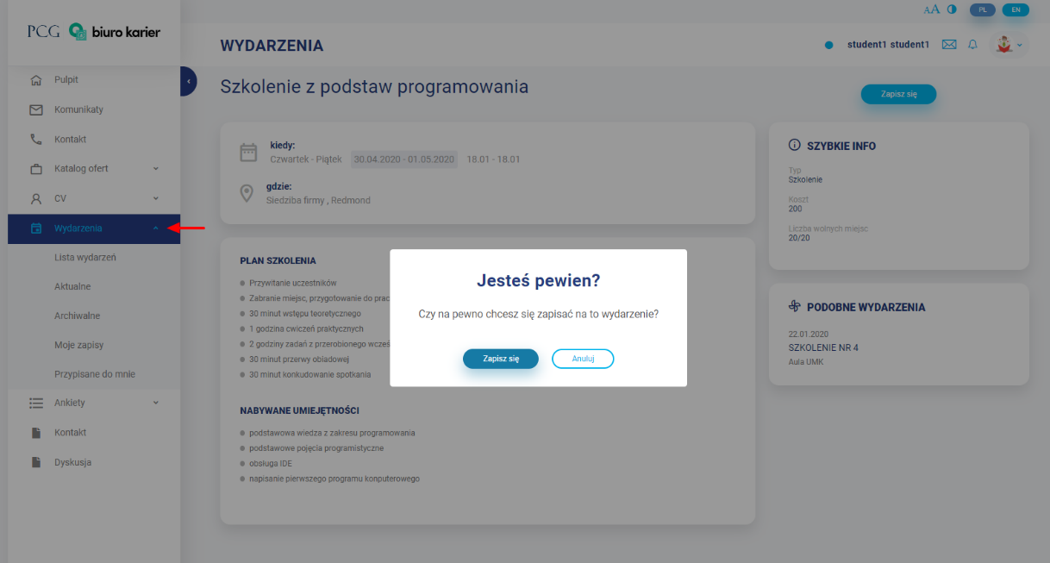
Events for which the user has signed up are visible in Moje zapisy (My records).

Surveys
In this part there are surveys that are sent to the user (he or she also receives an e-mail with a link to fill out). New surveys are those that are waiting to be completed. Completed surveys are those that the user has already answered.
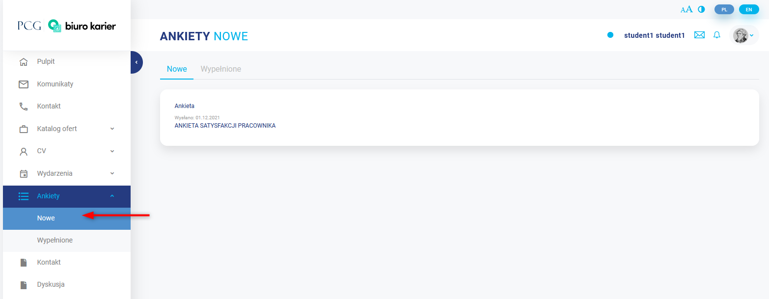
To complete a survey, the user should click on its name in the list of new surveys.
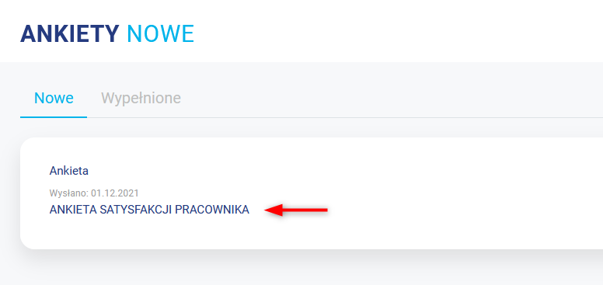

Next he or she completes the form.
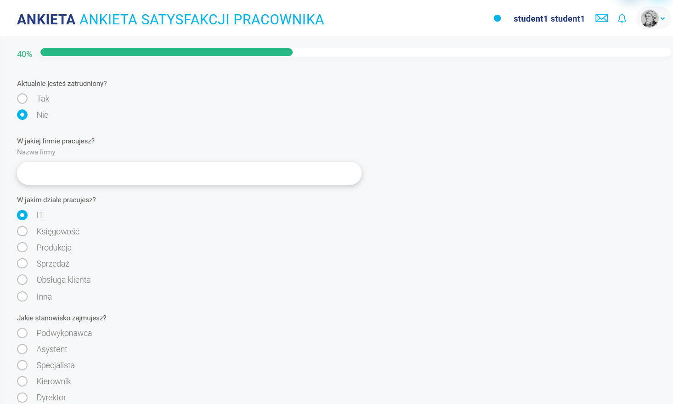

The completed survey is sent by pressing the button Dalej (Further).
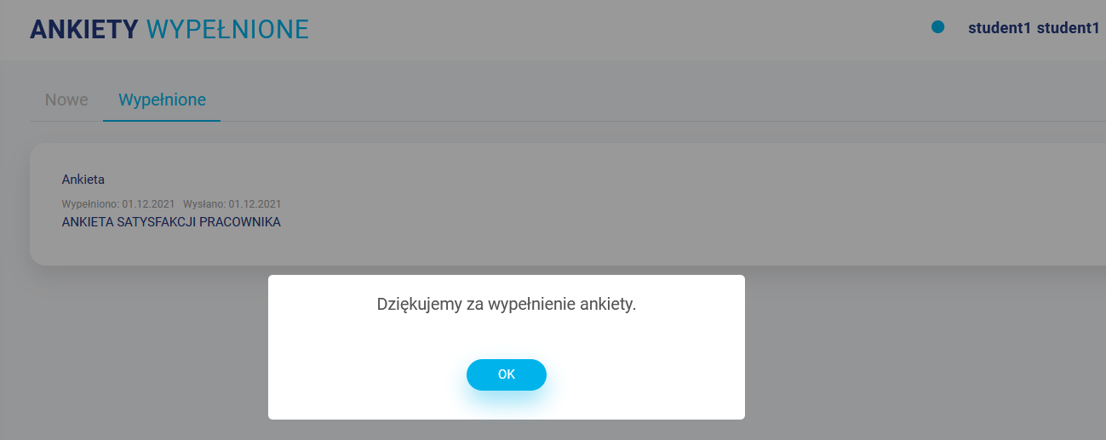
After sending the survey, the user is transferred to the list of completed surveys.

News
This section contains the list of the news posted by the Career Office.
