INSTRUCTIONS FOR REGISTERING A NEW USER
IN THE ON-LINE CATALOG

- Go to the website: www.wsb.edu.pl/biblioteka.

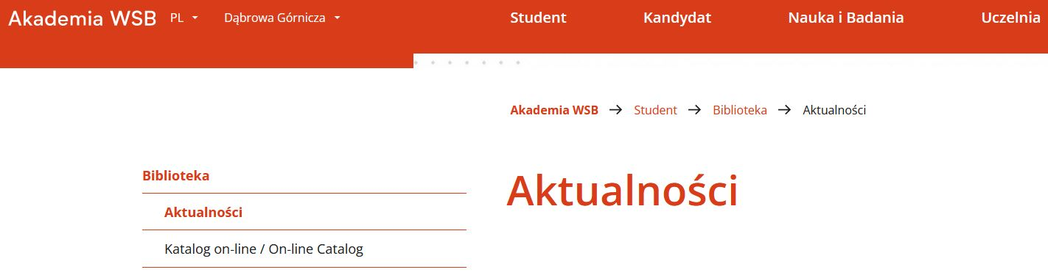
- In the left menu select the tab Katalog on-line/ On-line catalog.

- At the top of the website use the Menu to select the English language – click Polski and then change the language.
- Choose Profile, then Sign Up.

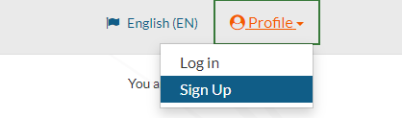

- Fill all fields. Fields marked with a red frame are mandatory. In Library department choose Stosunki Międzynarodowe. Lending department should be the same as the city where you study.
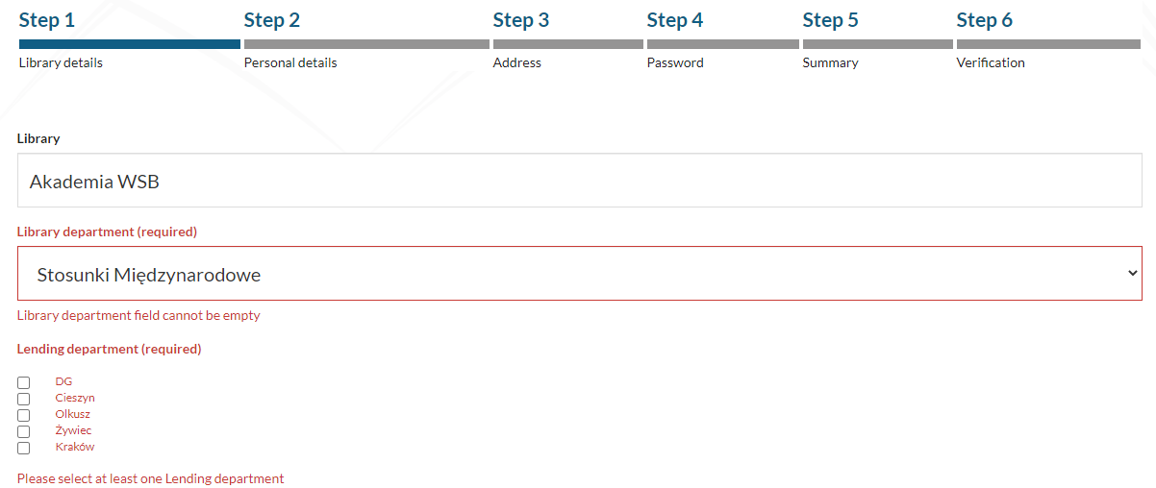
Step 2 - fill all required fields and:
- Id type: Legitymacja – a green student card;
- Id number: Numer albumu – check on your student card.
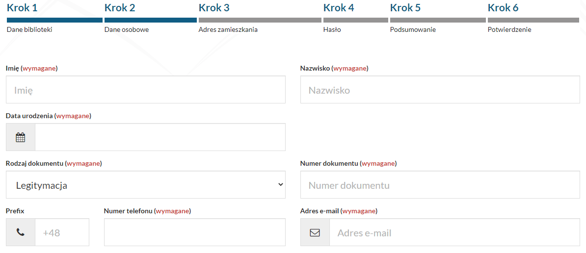
Step 3 requires your home address (you can also provide an alternative address).
Step 4 - set a password as required.
Step 5 - check and confirm the entered data.
At the end – step 6 - enter the code from the picture and give your consent.
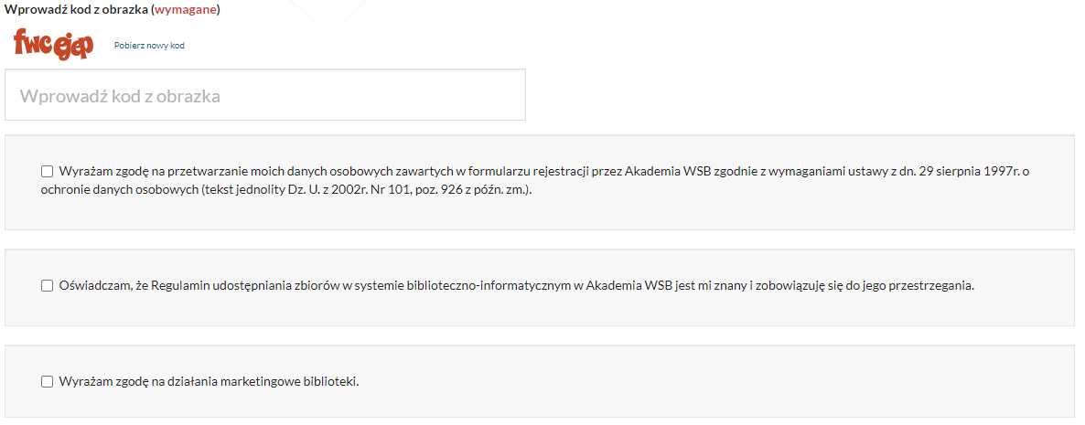

The ID is your LOGIN to the library catalog, therefore it should be kept.
After the registration the account will be locked. Within 2 working days a library employee will verify and activate your account.

