INSTRUCTIONS FOR ORDERING BOOKS
- Go to the website: www.wsb.edu.pl/biblioteka.

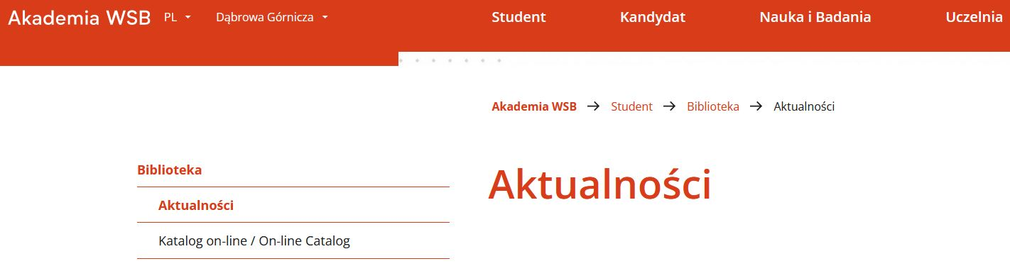
- In the left menu select the tab Katalog on-line/
On-line catalog.

- At the top of the website use the Menu to select the English language – click Polski and then change the language.

- In the upper right corner choose Profile, then Log in and input your ID and password.

- Search the Catalog for the item you are interested in, then click on Details to view the description

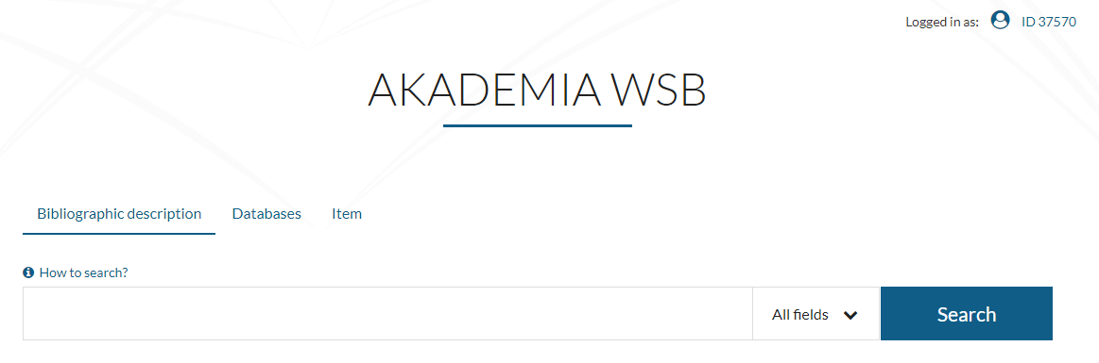
- If a book is loanable and available, click Request. Requests go to your Requests cart.
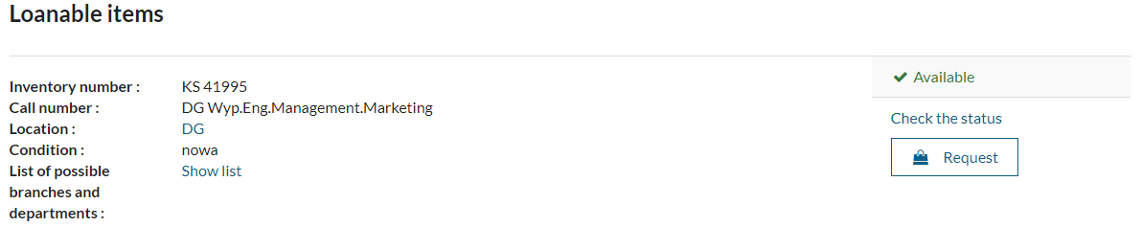
- If an item is available on-site only, it means that you can use this book only in the Reading room.

- Repeat steps 5 and 6 with all books which you want to order – Continue browsing. When you have all needed books in the cart choose Go to the request cart.
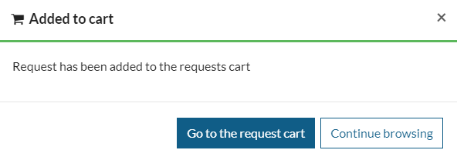
- Accept your order by clicking Confirm request.
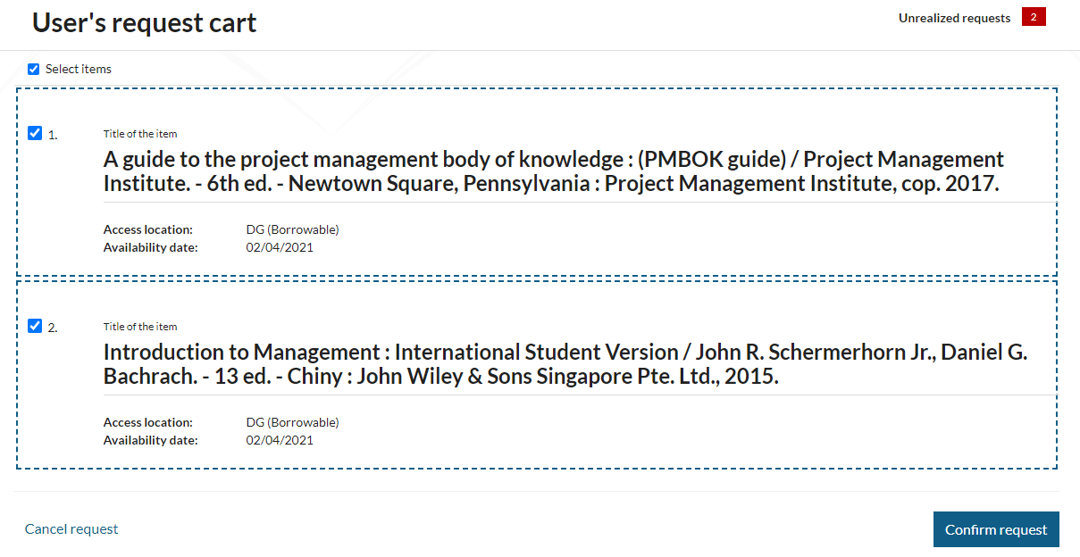
ATTENTION! If you skip Confirm request, the given order will not reach the Library and will not be processed by the employee.
- If the procedure is performed correctly, the order is processed within the specified time and the book is waiting for collection for 3 days.

- After this period, the system will automatically cancel the ordered books from the Reader's account, giving the possibility of re-ordering.

- At the same time, the reader receives by e-mail all information about the status of the ordered book. You can check the status of the implementation by going to your account in the Ordered documents tab.

