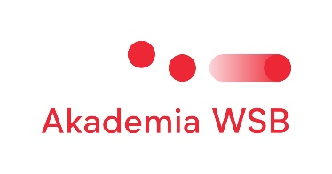



Sunday 12th May

19:00- 21.00 Welcome reception at Holiday Inn (roof top) Dąbrowa Górnicza

Monday 13th

9:30 — 10:00 Registration of participants

10:00 - 10:10 Welcome note — Rafat Rebilas, PhD - Vice Rector for International Cooperation, WSB University

10:10 — 11:00 Ice breaking

11:00 — 13:00 How can we give our students a global experience without traveling? Workshop by Eva Haug

13:00 — 14:00 Lunch in university canteen

14:00 — 16:00 How can we give our students a global experience without traveling? Workshop by Eva Haug

16:00 — 16:30 Tour around university

Tuesday 14th

10:00 — 12:00 Presentations of participants and their home universities

12:00 — 13:00 Lunch in university canteen (provided by WSBU)

13:00 — 14:30 Presentations of participants and their home universities

15:00 — 17:30 Trip to Katowice by shuttle bus: visit to Silesian Museum & Nikiszowiec Neighbourhood

19:00 — 21:00 Dinner in 'TATIANA' Restaurant in Katowice

21:30 — Return to Dąbrowa Górnicza by shuttle bus

Wednesday 15th

10:00 — 12:00 About BIP programs

12:00 — 13:00 Lunch in university canteen

13:00 — 14:00 About BIP programs from students’ percpective

14:00 – 16:00 How can we give our students a global experience without traveling? Workshop by Eva Haug

19:00 Jam Session in Katowice

Thursday 16th

10:00 - 12:00 Interactive discussion session moderated by IRO Office/  
12:00 — 13:00 Lunch in university canteen

13:00 — 15:00 International Coffee Break — participants to bring their traditional food and drink for sharing

15:00 — lectures by participants doing Staff Mobility for Teaching / other participants have free time

Friday 12th

9:00 — a day trip to Kraków: visiting the city with a tour guide.

The shuttle bus will leave Dąbrowa Górnicza at 9:00h and will pick up participants from their hotels in Dąbrowa G6rnicza. Bus will leave Kraków at 19:00 and return to Dąbrowa Górnicza.