

StudentlD – electronic student id cards(mlegitymacje)

Log-in instructions for students

To log into the Electronic Student ID System, please open in any web browser (e.g. Firefox, Safari, Chrome, Edge, Opera, etc.) the :

[https:/ /studentid.wsb.edu.pl](https://studentid.wsb.edu.pl/)

Once you have opened the link, you should be taken to the following page:

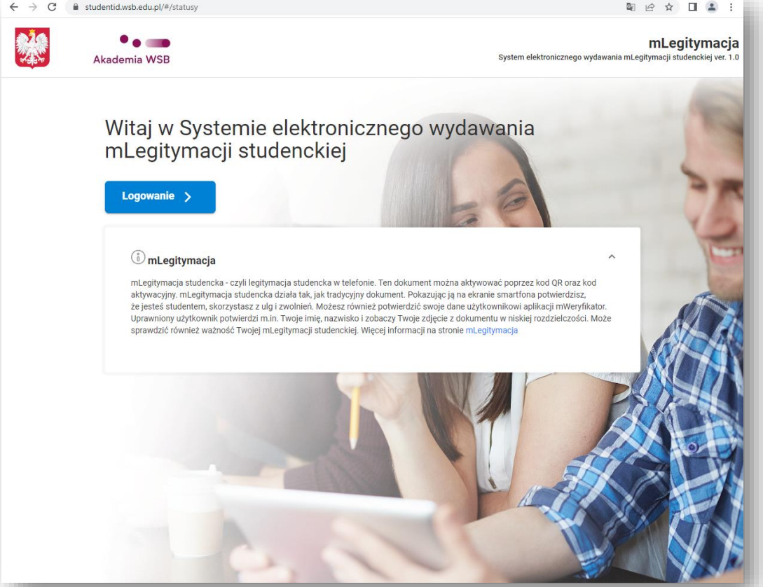

To log in, click on the ‘Logowanie’ button. You will then be taken to the login page (see image below). There you must enter the same credentials as for logging in to your student mailbox.

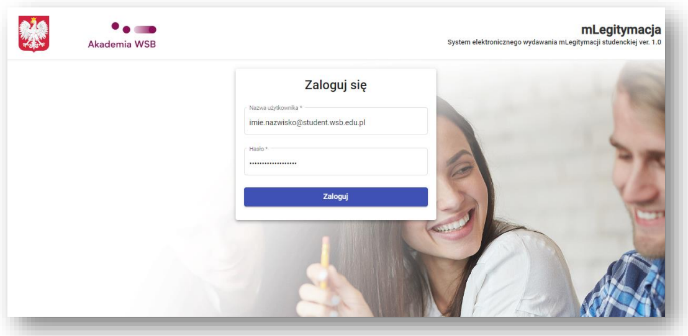

Once you have correctly logged in, you can request (if you have not already done so) the generation of an ID. To do this, click on the ‘Zleć’ button.

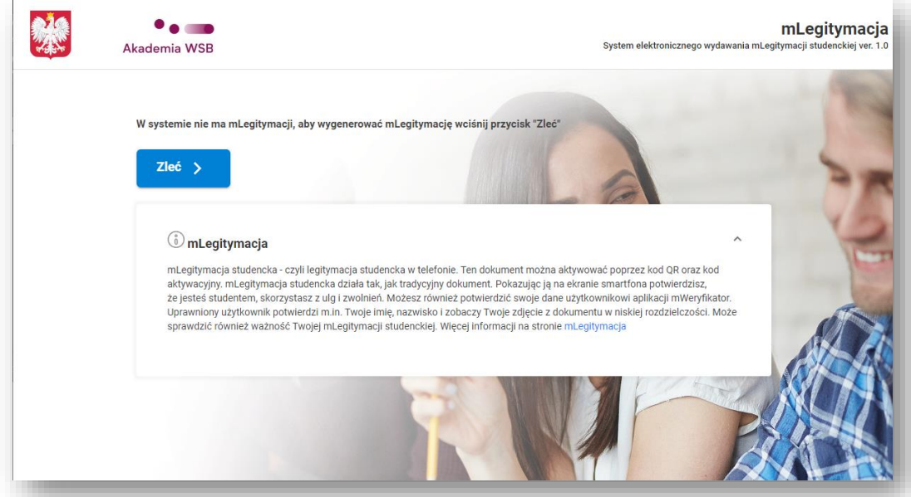

Once the user has initiated the generation of the id card, the information about the correctness of the process is displayed.

You will need to wait for feedback from the system before the id card is ready for collection. This can usually take up to 30 minutes. The status can be verified again by clicking on the ‘Odśwież’ button.

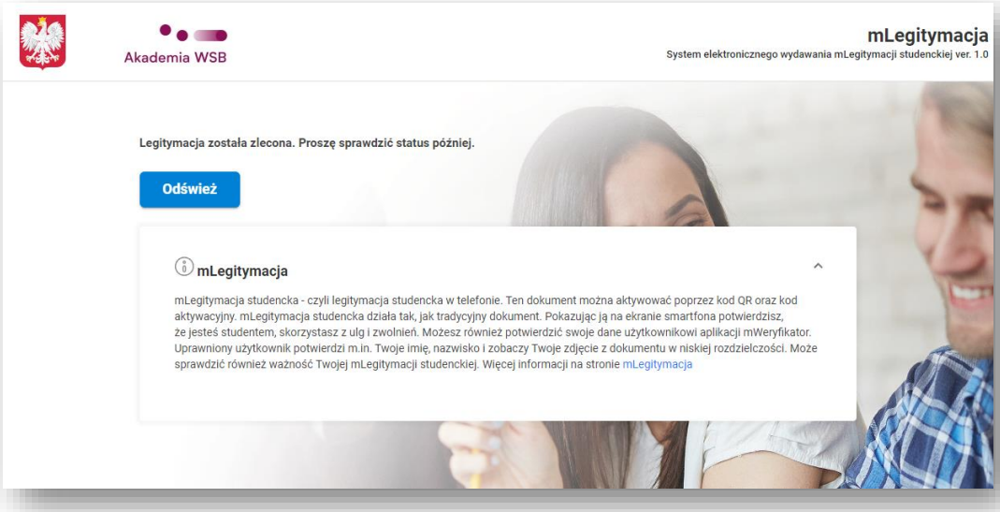

When the identity card is ready for collection, the message "mlegitymacja jest gotowa do odbioru" will appear on the website. Then follow the instructions displayed on the page. An Android or iOS device and the mObywatel app are required. Detailed information on adding documents to the mCitizen app can be found on the following page:

<https://www.gov.pl/web/mobywatel-w-aplikacji/mobywatel-dokument>

If the document has been correctly added to mObywatel app, click the ‘Potwierdź odbiór’ button. You can use the following page to ensure that the document has been correctly added:

<https://www.gov.pl/web/mobywatel-w-aplikacji/mlegitymacja-studencka>

A document added in accordance with the above guidelines should already be available in the mObywatel app.

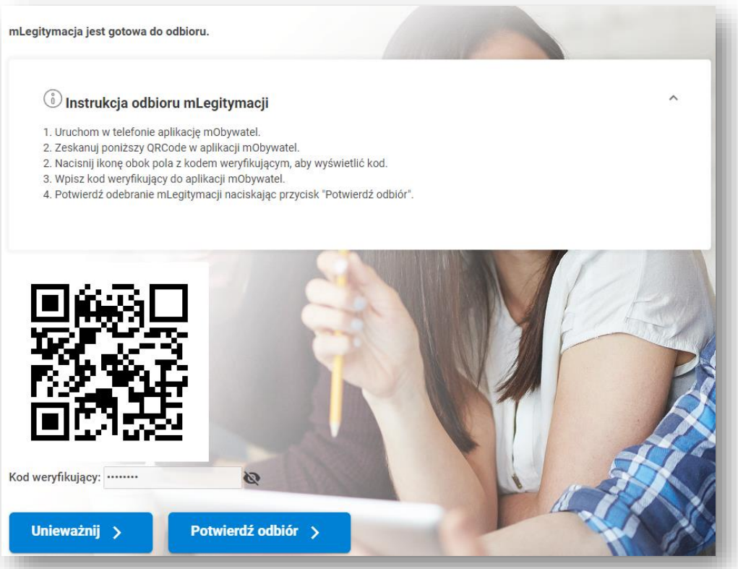

Correctly adding a document and confirming it in the application will take you to a page where you can cancel the document.

If you do not wish to cancel the document, you must log out of the system and exit the page.

